**INTRODUCTION**

**Merits and Demerits of the Project**

**Study Tools**

1. **CALCULATOR**

**Merits:-**

1. Calculates same as the **general calculator**
2. Efficient to calculate **Cube Root**
3. Efficient to calculate **Trigonometric Values**

**Demerits:-**

1. Inefficient to change the sing of the input/output
2. Operator is to be inserted initially and then the operand contrast to the general functioning of calculator
3. **FORMULAE BOOK OF MATHEMATICS (BASED ON THE SYLLABUS OF ICSE STANDARD IX & X)**

**Merits:-**

1. Includes most of the concepts of Mathematics based on syllabus of **ICSE standard IX & X**.
2. Includes **43 concepts**of Mathematics
3. Efficient in calculating **Statistical Data**

**Demerits:-**

1. Lacks some of the concepts
2. Inefficient to calculate Mode and Median of grouped data
3. Very limited Applicable in Algebra
4. **HEALTH ANALYSIS (BASED ON BODY MASS INDEX (BMI))**

**Merits:-**

1. **Accurately calculates** Body Mass Index of the user

**Demerits:-**

1. Inefficient in flexibility of units
2. **PERTIODIC TABLE**

**Merits:-**

1. Enables user to **access information of required element according to requirement**

**Demerits:-**

1. Inefficient to help if user does not know the atomic number of the element required
2. **OVER ALL APPLICATION**

**Merits:-**

1. Specially designed program : does not **terminates in any kind of run time error**

**(Run Time Error Fixation Feature of the “STUDY TOOLS” program)**

1. Wait Function is specially designed for the **user convenience and user friendly feature**
2. Provides **maximum user friendly feature**

**Demerits:-**

1. Inefficient to retrieve in case of too many invalid inputs while execution of wait function
2. Inefficient to ignore case

**CONCEPTS USED IN THE PROJECT**

1. **Type Conversion**
2. **Operators**
3. Arithmetical Operators
4. Unary Operators
5. Binary Operators
6. Relational Operators
7. Logical Operators
8. **Mathematical Functions**
9. **Input methods**
10. Stream Reader
11. Scanner Class
12. Data Input Stream
13. **Decision Making**
14. If – condition
15. If-else condition
16. Nested If –condition
17. Multiple If-condition
18. **Menu Driven program**
19. Switch Case
20. Nested Switch Case
21. **Iteration Through Loops**
22. For Loop
23. Nested Loop
24. Null Loop
25. Do-While Loop
26. Use Of Break Statement
27. User Controlled Loop
28. **Using Library Classes**
29. Java.io
30. Java.util
31. **Exception Handling**
32. Using Throws Key Word
33. Using Try Catch Block
34. Use Of Finally Key Word
35. **String Manipulation**
36. Character Functions
37. String Functions
38. **Arrays**
39. Single Dimension Array
40. Double Dimension Array
41. Operation On Array
42. Soarting
43. Selection Sort
44. Bubble Sort
45. **Functions / Methods**
46. Procedural Function

**CODING OF THE STUDY TOOL APPLICATION**

public class Introduction

{

Wait obj=new Wait();

public void Introduction()

{

System.out.println("|-----------------------------------------------------------------------READ ME----------------------------------------------------------------------|");

System.out.println("| |");

System.out.println("| TITLE: |");

System.out.println("| STUDY TOOLS APPLICATION |");

System.out.println("| |");

System.out.println("| PURPOSE: |");

System.out.println("| ANNUAL COMPUTER PROJECT FOR YEAR 2014-15 |");

System.out.println("| |");

System.out.println("| VERSION: |");

System.out.println("| 2014-15 |");

System.out.println("| |");

System.out.println("| AUTHOR: |");

System.out.println("| ATHARV BALASAHEB DAREKAR |");

System.out.println("| |");

System.out.println("| STD: |");

System.out.println("| X |");

System.out.println("| |");

System.out.println("| ROLL NUMBER: |");

System.out.println("| AO-011 |");

System.out.println("| |");

System.out.println("| USER INSTRUCTIONS: |");

System.out.println("| 1.READ THE INSTRUCTIONS CAREFULLY AND EXECUTE COMMANDS |");

System.out.println("| 2.PLEASE DO NOT MAKE CHANGES IN PROGRAM FILES |");

System.out.println("| |");

System.out.println("| !!!THANK YOU!!! |");

System.out.println("|____________________________________________________________________________________________________________________________________________________|");

obj.WaitForIntroduction();

}

}

import java.util.*;

import java.io.*;

public class Project_2014_15

{

public static void main(String atharv[])throws IOException

{

Scanner A=new Scanner(System.in);

FormulaeBookMathematics obj=new FormulaeBookMathematics();

NewCalculator obj1=new NewCalculator();

PERIODICTABLE obj2=new PERIODICTABLE();

BMI obj3=new BMI();

Wait obj4=new Wait();

Introduction obj5=new Introduction();

String choice;

boolean e=false;

int i=0,i1=0;

do

{

if(i1!=1)

{

obj5.Introduction();

System.out.println("");

System.out.println("");

System.out.println("");

System.out.println("");

System.out.println("");

i1++;

}

if(i!=1)

{

System.out.println("********************* WELCOME TO STUDY TOOLS APPLICATION PROGRAMMED BY ATHARV DAREKAR FOR ACADEMYC YEAR 2014-15 ********************");

System.out.println("____________________________________________________________________________________________________________________________________");

obj4.Wait1();

i++;

}

System.out.println(" _____________________________________________________________________________________________________________________");

System.out.println("| |");

System.out.println("| SELECT A SUBJECT |");

System.out.println("| |");

System.out.println("| 1.CALCULATOR |");

System.out.println("| |");

System.out.println("| 2.FORMULAE BOOK OF MATHEMATICS (BASED ON THE SYLLABUS OF ICSE STANDARD IX & X) |");

System.out.println("| |");

System.out.println("| 3.HEALTH ANALYSIS (BASED ON BODY MASS INDEX (BMI)) |");

System.out.println("| |");

System.out.println("| 4.PERTIODIC TABLE |");

System.out.println("| |");

System.out.println("| ENTER 'EXIT' TO EXIT |");

System.out.println("|_____________________________________________________________________________________________________________________|");

System.out.println("");

System.out.println("NOTE :- ON CAPS LOCK BUTTON PLEASE");

System.out.println("");

System.out.println("ENTER YOUR CHOICE");

choice=A.nextLine();

switch(choice)

{

case "1":

{

obj1.NewCalculator();

obj4.Wait();

System.out.println();

}

break;

case "2":

{

obj.FormulaeBookMathematics();

obj4.Wait();

System.out.println();

}

break;

case "3":

{

obj3.BMI();

obj4.Wait();

System.out.println();

}

break;

case "4":

{

obj2.Periodictable();

obj4.Wait();

System.out.println();

}

break;

case "EXIT":

{

System.out.println("*********************************************************** THANK YOU *************************************************************");

e=true;

}

break;

default:

{

System.out.println("ERROR INVALID OPTION PLEASE TRY AGAIN");

obj4.Wait1();

}

}

}while(e==false);

}

}

import java.util.*;

import java.io.*;

public class NewCalculator

{

Scanner A=new Scanner(System.in);

DataInputStream A2=new DataInputStream(System.in);

Wait obj=new Wait();

boolean flag=false;

void NewCalculator()throws IOException

{

try

{

double result=0,ind;

boolean e1=false,e2=false;

double an,si,co,ta;

double round,cbrt,d;

int cbrtint;

float df;

String ins,t,charat0s,in;

char charat0;

double pi=((22/7)+(355/113))/2;

System.out.println("");

System.out.println("**********************************WELCOME TO CALCULATOR PROGRAMMED BY ATHARV DAREKAR**********************************");

System.out.println("");

obj.Wait1();

do

{

System.out.println();

System.out.println("ENTER NUMBER TO BE OPERATED ALONG WITH THE OPERATOR AS SHOWN BELOW :");

System.out.println("'+25' TO ADD\n'-56' TO SUBTRACT\n'*85' TO MULTIPLY\n'/87' TO DIVIDE\n'%54' TO FIND MOD\n'|4' TO FIND SQUARE ROOT\n'!8' TO FIND CUBE ROOT\n'^2' TO FIND POWER OF THE BASE");

System.out.println("'T' FOR TRIGENOMETRICAL RATIOS");

System.out.println("");

System.out.println("ENTER '=' FOR RESULT");

System.out.println("ENTER AND RE-ENTER '==' TO RE-SET CALCULATOR");

System.out.println();

System.out.print(result);

do

{

ins=A.nextLine();

charat0=(ins.charAt(0));

charat0s=Character.toString(charat0);

if(charat0s.equals("/"))

{

t=ins.replace("/","");

ind=Double.parseDouble(t);

if(ind!=0)

{

result*=(1/ind);

}

else

{

System.out.println("INFINITY");

}

}

if(charat0s.equals("+"))

{

t=ins.replace("+","");

ind=Double.parseDouble(t);

result+=ind;

}

if(charat0s.equals("-"))

{

t=ins.replace("-","");

ind=Double.parseDouble(t);

result-=ind;

}

if(charat0s.equals("*"))

{

t=ins.replace("*","");

ind=Double.parseDouble(t);

result*=ind;

}

if(charat0s.equals("|"))

{

t=ins.replace("|","");

ind=Double.parseDouble(t);

result=Math.sqrt(ind);

}

if(charat0s.equals("!"))

{

t=ins.replace("!","");

ind=Double.parseDouble(t);

cbrt=Math.pow(ind,Math.pow(3,-1));

cbrtint=(int)(cbrt);

d=cbrt-cbrtint;

df=(float)(d);

if((df>=0.9998888))

{

round=Math.round(cbrt);

}

else

{

round=cbrt;

}

result=round;

}

if(charat0s.equals("%"))

{

t=ins.replace("%","");

ind=Double.parseDouble(t);

if(ind!=0)

{

result%=ind;

}

else

{

System.out.println("INFINITY");

}

}

if(charat0s.equals("^"))

{

t=ins.replace("^","");

ind=Double.parseDouble(t);

result=Math.pow(result,ind);

}

if(ins.equals("T"))

{

System.out.println("1.Sine OF AN ANGLE");

System.out.println("2.Cosecant OF AN ANGLE");

System.out.println("3.Tangent OF AN ANGLE");

String m=(A2.readLine());

switch (m)

{

case "1":

{

System.out.println("ENTER VALUE FOR ANGLE");

an=Double.parseDouble(A2.readLine());

si=(pi*an)/180;

System.out.println("Sine VALUE OF GIVEN ANGLE IS\t"+Math.sin(si));

}

break;

case "2":

{

System.out.println("ENTER VALUE FOR ANGLE");

an=Double.parseDouble(A2.readLine());

co=(pi*an)/180*an;

System.out.println("Cosecant VALUE OF GIVEN ANGLE IS\t"+Math.cos(co));

}

break;

case "3":

{

System.out.println("ENTER VALUE FOR ANGLE");

an=Double.parseDouble(A2.readLine());

ta=(pi*an)/180*an;

System.out.println("Tangent VALUE OF GIVEN ANGLE IS\t"+Math.tan(ta));

}

break;

default:

System.out.println("ERROR INVALID OPTION PLEASE TRY AGAIN");

obj.Wait1();

}

}

System.out.println(result);

if(ins.equals("=="))

result=0;

if(ins.equals("="))

e1=true;

}while(e1==false);

System.out.println("PRESS 'ENTER' TO CONTINUE ELSE ENTER 'EXIT' TO EXIT CALCULATOR");

in=A.nextLine();

e1=false;

if(in.equals("EXIT"))

e2=true;

}while(e2==false);

}catch(Exception e){flag=true;}

finally

{

if(flag==true)

{

System.out.println("RUN-TIME ERROR COMMITED");

obj.Wait1();

System.out.println("RESOLVING PLEASE WAIT");

obj.Wait1();

System.out.println("ERROR RESOLVED");

obj.Wait1();

}

}

}

}

import java.io.*;

public class FormulaeBookMathematics

{

UpdateFormulaeBook obj=new UpdateFormulaeBook();

BufferedReader A=new BufferedReader (new InputStreamReader(System.in));

Wait obj1=new Wait();

boolean flag=false;

void FormulaeBookMathematics()throws IOException

{

try

{

double p,r,t,si,ci,i,s1,s2,s3,l,b,h,hy,tsa,csa,lsa,s,v,c,a,p1,p2,d1,d2,d,ue,e,s123,eacha,n,amt;

String opt,ch;

boolean ei=false;

String eorc;

System.out.println("");

System.out.println("**********************************WELCOME TO FORMULAE BOOK OF MATHEMATICS PROGRAMMED BY ATHARV DAREKAR**********************************");

System.out.println("");

obj1.Wait1();

do

{

System.out.println();

System.out.println("SELECT CATEGORY");

System.out.println("111.COMMERCIAL MATHEMATICS");

System.out.println("222.ALGEBRA");

System.out.println("333.CO-ORDINATE GEOMETRY");

System.out.println("444.GEOMETRY");

System.out.println("555.MENSURATION");

System.out.println("666.STATISTICS");

System.out.println("ENTER YOUR CHOICE");

ch=(A.readLine());

switch (ch)

{

case "111":

{

System.out.println("COMMERCIAL MATHEMATICS");

System.out.println("1.SIMPLE INTEREST");

System.out.println("2.COMPOUND INTEREST");

System.out.println("3.AMOUNT");

}

break;

case "222":

{

System.out.println("ALGEBRA");

System.out.println("42.QUADRATIC EQUATIONS");

System.out.println("43.MATRICE ADDITION");

}

break;

case "333":

{

System.out.println("CO-ORDINATE GEOMETRY");

System.out.println("41.EQUATION OF LINE");

}

break;

case "444":

{

System.out.println("GEOMETRY");

System.out.println("4.PYTHAGORAS THEOREM");

System.out.println("5.ANGLE SUM OF POLYGONS");

System.out.println("6.VALUE OF AN ANGLE OF AN EQUILATERAL POLYGON");

}

break;

case "555":

{

System.out.println("MENSURATION");

System.out.println("7.AREA OF TRIANGLE (HERONS Formuela)");

System.out.println("8.AREA OF TRIANGLE (RIGHT ANGLED TRIANGLE)");

System.out.println("9.AREA OF TRIANGLE (EQUILATERAL TRIANGLE)");

System.out.println("10.AREA OF TRIANGLE (ISOSCELES TRIANGLE)");

System.out.println("11.AREA OF QUADRILATERAL (IRREGULAR)");

System.out.println("12.AREA OF RECTANGEL");

System.out.println("13.AREA OF SQARE");

System.out.println("14.AREA OF PARALLALOGRAM");

System.out.println("15.AREA OF RHOMBUS");

System.out.println("16.AREA OF TRAPEZIUM");

System.out.println("17.AREA OF CIRCLE");

System.out.println("18.AREA OF CONCENTRIC CIRCLE");

System.out.println("19.CIRCUMFERANCE OF CIRCLE");

System.out.println("20.SURFACE AREA OF CUBOID ");

System.out.println("21.SURFACE AREA OF CUBE");

System.out.println("22.SURFACE AREA OF CYLINDER");

System.out.println("23.VOLUME OF CUBOID");

System.out.println("24.VOLUME OF CUBE");

System.out.println("25.VOLUME OF CYLINDER");

System.out.println("26.LATREL SURFACE AREA OF CUBOID");

System.out.println("27.LATREL SURFACE AREA OF CUBE");

System.out.println("28.CURVED SURFACE AREA OF CYLINDER");

System.out.println("29.VOLUME OF CONE");

System.out.println("30.CURVED SURFACE AREA OF CONE");

System.out.println("31.TOTAL SURFACE AREA OF CONE");

System.out.println("32.VOLUME OF SPHERE");

System.out.println("33.SURFACE AREA OF SPHERE");

System.out.println("34.SPHERICAL SHELL");

System.out.println("35.VOLUME OF HEMISPHERE");

System.out.println("36.TOTAL SURFACE AREA OF HEMISPHERE");

}

break;

case "666":

{

System.out.println("666.STATISTICS");

System.out.println("37.MEAN");

System.out.println("38.MEAN OF GROUPED DATA");

System.out.println("39.MEDIAN");

System.out.println("40.QUARTILE");

}

break;

default:

{

System.out.println("ERROR INVALID OPTION PLEASE TRY AGAIN");

obj1.Wait1();

System.out.println("ENTER 'EXIT' AND PLEASE TRY AGAIN");

}

}

opt=(A.readLine());

switch (opt)

{

case "1":

{

System.out.println("ENTER VALUE FOR PRINCIPLE/CAPITAL");

p=Double.parseDouble(A.readLine());

System.out.println("ENTER VALUE FOR RATE %(PER ANNUM)");

r=Double.parseDouble(A.readLine());

System.out.println("ENTER VALUE FOR TIME SPAN (YEAR)");

t=Double.parseDouble(A.readLine());

si=p*r*t/100;

System.out.println("SIMPLE INTEREST Rs."+si);

}

break;

case "2":

{

System.out.println("ENTER VALUE FOR PRINCIPLE/CAPITAL");

p=Double.parseDouble(A.readLine());

System.out.println("ENTER VALUE FOR RATE %(PER ANNUM)");

r=Double.parseDouble(A.readLine());

System.out.println("ENTER VALUE FOR TIME SPAN (YEAR)");

t=Double.parseDouble(A.readLine());

ci=(p*(Math.pow((100+r/100),t)))-p;

System.out.println("COMPOUND INTEREST Rs."+ci);

}

break;

case "3":

{

System.out.println("ENTER VALUE FOR PRINCIPLE/CAPITAL");

p=Double.parseDouble(A.readLine());

System.out.println("ENTER VALUE FOR COMPOUND/SIMPLE INTEREST");

i=Double.parseDouble(A.readLine());

amt=p+i;

System.out.println("AMOUNT Rs."+amt);

}

break;

case "4":

{

String z;

System.out.println("1.TO FIND HYPOTENUSE");

System.out.println("2.TO FIND BASE");

System.out.println("3.TO FIND HIGHT");

z=(A.readLine());

switch (z)

{

case "1":

{

System.out.println("ENTER VALUE FOR HEIGHT");

h=Double.parseDouble(A.readLine());

System.out.println("ENTER VALUE FOR BASE");

b=Double.parseDouble(A.readLine());

hy=Math.sqrt((h*h+b*b));

System.out.println("HYPOTENUSE OF THE TRIANGLE "+hy);

}

break;

case "2":

{

System.out.println("ENTER VALUE FOR HEIGHT");

h=Double.parseDouble(A.readLine());

System.out.println("ENTER VALUE FOR Hypotenus");

hy=Double.parseDouble(A.readLine());

b=Math.sqrt((hy*hy-h*h));

System.out.println("BASE OF THE TRIANGLE "+b);

}

break;

case "3":

{

System.out.println("ENTER VALUE FOR Hypotenus");

hy=Double.parseDouble(A.readLine());

System.out.println("ENTER VALUE FOR BASE");

b=Double.parseDouble(A.readLine());

h=Math.sqrt((hy*hy-b*b));

System.out.println("HEIGHT OF THE TRIANGLE "+h);

}

break;

default:

{

System.out.println("ERROR INVALID OPTION PLEASE TRY AGAIN");

obj1.Wait1();

}

}

}

break;

case "5":

{

System.out.println("ENTER NUMBER OF SIDES OF THE POLYGON");

n=Double.parseDouble(A.readLine());

a=(2*n-4)*90;

System.out.println("ANGLE SUM OF THE POLYGON "+a+"*");

}

break;

case "6":

{

System.out.println("ENTER NUMBER OF SIDES OF THE POLYGON");

n=Double.parseDouble(A.readLine());

eacha=((2*n-4)*90)/n;

System.out.println("EACH ANGLE OF THE MEASURES "+eacha);

}

break;

case "7":

{

System.out.println("ENTER VALUE FOR SIDE 1");

s1=Double.parseDouble(A.readLine());

System.out.println("ENTER VALUE FOR SIDE 2");

s2=Double.parseDouble(A.readLine());

System.out.println("ENTER VALUE FOR SIDE 3");

s3=Double.parseDouble(A.readLine());

s123=(s1+s2+s3)/2;

a=Math.sqrt((s123-s1)*(s123-s2)*(s123-s3));

System.out.println("THE AREA OF THE TRIANGLE "+a);

}

break;

case "8":

{

System.out.println("ENTER VALUE FOR HEIGHT");

h=Double.parseDouble(A.readLine());

System.out.println("ENTER VALUE FOR BASE");

b=Double.parseDouble(A.readLine());

a=h*b*0.5;

System.out.println("THE AREA OF THE TRIANGLE "+a);

}

break;

case "9":

{

System.out.println("ENTER VALUE FOR SIDE");

s=Double.parseDouble(A.readLine());

a=s*s*(Math.sqrt(3)/4);

System.out.println("THE AREA OF THE TRIANGLE "+a);

}

break;

case "10":

{

System.out.println("ENTER VALUE FOR EQUAL SIDES");

e=Double.parseDouble(A.readLine());

System.out.println("ENTER VALUE FOR UNEQUAL SIDE");

ue=Double.parseDouble(A.readLine());

a=ue*0.25*Math.sqrt(e*e*4-ue*ue);

System.out.println("THE AREA OF THE TRIANGLE "+a);

}

break;

case "11":

{

System.out.println("ENTER VALUE FOR DIAGONAL");

d=Double.parseDouble(A.readLine());

System.out.println("ENTER VALUE FOR 1 PERPENDICUALR TO THE DIAGONAL");

d1=Double.parseDouble(A.readLine());

System.out.println("ENTER VALUE FOR 2 PERPENDICUALR TO THE DIAGONAL");

d2=Double.parseDouble(A.readLine());

a=(d/2)*(d1+d2);

System.out.println("AREA OF THE IRREGUAL QUADRILATERAL "+a);

}

break;

case "12":

{

System.out.println("ENTER VALUE FOR LENGHT");

l=Double.parseDouble(A.readLine());

System.out.println("ENTER VALUE FOR BREADTH");

b=Double.parseDouble(A.readLine());

a=l*b;

System.out.println("AREA OF THE RECTANGLE "+a);

}

break;

case "13":

{

System.out.println("ENTER VALUE FOR SIDE");

s=Double.parseDouble(A.readLine());

a=s*s;

System.out.println("AREA OF THE SQUARE"+a);

}

break;

case "14":

{

System.out.println("ENTER VALUE FOR HEIGHT");

h=Double.parseDouble(A.readLine());

System.out.println("ENTER VALUE FOR BASE");

b=Double.parseDouble(A.readLine());

a=b*h;

System.out.println("AREA OF THE PARALLELOGRAM "+a);

}

break;

case "15":

{

System.out.println("ENTER VALUE FOR DIAGONAL 1");

d1=Double.parseDouble(A.readLine());

System.out.println("ENTER VALUE FOR DIAGONAL 2");

d2=Double.parseDouble(A.readLine());

a=d1*d2*0.5;

System.out.println("AREA OF THE RHOMBUS "+a);

}

break;

case "16":

{

System.out.println("ENTER VALUE FOR HEIGHT");

h=Double.parseDouble(A.readLine());

System.out.println("ENTER VALUE FOR PARALLEL 1");

p1=Double.parseDouble(A.readLine());

System.out.println("ENTER VALUE FOR PARALLEL 2");

p2=Double.parseDouble(A.readLine());

a=(p1+p2)*h*0.5;

System.out.println("AREA OF THE TRAPEZIUM "+a);

}

break;

case "17":

{

System.out.println("ENTER VALUE FOR RADIUS");

r=Double.parseDouble(A.readLine());

a=r*r*22/7;

System.out.println("AREA OF THE CIRCLE "+a);

}

break;

case "18":

{

obj.AreaOfConcentricCircles();

}

break;

case "19":

{

System.out.println("ENTER VALUE FOR RADIUS");

r=Double.parseDouble(A.readLine());

c=r*2*22/7;

System.out.println("CIRCUMFERANCE OF THE CIRCLE "+c);

}

break;

case "20":

{

System.out.println("ENTER VALUE FOR LENGHT");

l=Double.parseDouble(A.readLine());

System.out.println("ENTER VALUE FOR BREADTH");

b=Double.parseDouble(A.readLine());

System.out.println("ENTER VALUE FOR HEIGHT");

h=Double.parseDouble(A.readLine());

tsa=(l*b+l*h+b*h)*2;

System.out.println("SURFACE AREA OF THE CUBOID "+tsa);

}

break;

case "21":

{

System.out.println("ENTER VALUE FOR SIDE");

s=Double.parseDouble(A.readLine());

tsa=s*s*6;

System.out.println("SURFACE AREA OF THE CUBE "+tsa);

}

break;

case "22":

{

System.out.println("ENTER VALUE FOR RADIUS");

r=Double.parseDouble(A.readLine());

System.out.println("ENTER VALUE FOR HEIGHT");

h=Double.parseDouble(A.readLine());

tsa=r*(h+r)*2*22/7;

System.out.println("SURFACE AREA OF THE CYLINDER "+tsa);

}

break;

case "23":

{

System.out.println("ENTER VALUE FOR LENGHT");

l=Double.parseDouble(A.readLine());

System.out.println("ENTER VALUE FOR BREADTH");

b=Double.parseDouble(A.readLine());

System.out.println("ENTER VALUE FOR HEIGHT");

h=Double.parseDouble(A.readLine());

v=l*b*h;

System.out.println("VOLUME OF THE CUBOID "+v);

}

break;

case "24":

{

System.out.println("ENTER VALUE FOR SIDE");

s=Double.parseDouble(A.readLine());

v=s*s*s;

System.out.println("VOLUME OF THE CUBE "+v);

}

break;

case "25":

{

System.out.println("ENTER VALUE FOR RADIUS");

r=Double.parseDouble(A.readLine());

System.out.println("ENTER VALUE FOR HEIGHT");

h=Double.parseDouble(A.readLine());

v=r*r*h*22/7;

System.out.println("VOLUME OF THE CYLINDER "+v);

}

break;

case "26":

{

System.out.println("ENTER VALUE FOR LENGTH");

l=Double.parseDouble(A.readLine());

System.out.println("ENTER VALUE FOR BREADTH");

b=Double.parseDouble(A.readLine());

System.out.println("ENTER VALUE FOR HEIGHT");

h=Double.parseDouble(A.readLine());

lsa=(l+b)*h*2;

System.out.println("LATREL SURFACE AREA OF THE CUBOID "+lsa);

}

break;

case "27":

{

System.out.println("ENTER VALUE FOR SIDE");

s=Double.parseDouble(A.readLine());

lsa=s*s*4;

System.out.println("LATERAL SURFACE AREA OF THE CUBE "+lsa);

}

break;

case "28":

{

System.out.println("ENTER VALUE FOR RADIUS");

r=Double.parseDouble(A.readLine());

System.out.println("ENTER VALUE FOR HEIGHT");

h=Double.parseDouble(A.readLine());

csa=r*h*2*22/7;

System.out.println("CURVED SURFACE AREA OF THE CYLINDER "+csa);

}

break;

case "29":

{

obj.VolumeOfCone();

}

break;

case "30":

{

obj.CurvedSurfaceAreaCone();

}

break;

case "31":

{

obj.TotalSurfaceAreaCone();

}

break;

case "32":

{

obj.VolumeOfSphere();

}

break;

case "33":

{

obj.SurfaceAreaOfSphere();

}

break;

case "34":

{

obj.SphericalShell();

}

break;

case "35":

{

obj.VolumeOfHemisphere();

}

break;

case "36":

{

obj.TotalSurfaceAreaHemisphere();

}

break;

case "37":

{

obj.Mean();

}

break;

case "38":

{

obj.MeanOfGroupedData();

}

break;

case "39":

{

obj.Median();

}

break;

case "40":

{

obj.Quartile();

}

break;

case "41":

{

obj.EquationOfLine();

}

break;

case "42":

{

obj.Discriminant();

}

break;

case "43":

{

obj.MatrixAddition();

}

break;

case "EXIT":

{

ei=true;

}

break;

default:

{

System.out.println("ERROR INVALID OPTION PLEASE TRY AGAIN");

obj1.Wait1();

}

}

System.out.println("PRESS 'ENTER' TO CONTINUE ELSE ENTER 'EXIT' TO EXIT FORMULAE BOOK OF MATHEMATICS");

eorc=A.readLine();

if(eorc.equals("EXIT"))

ei=true;

}while(ei==false);

}catch(Exception e){flag=true;}

finally

{

if(flag==true)

{

System.out.println("RUN-TIME ERROR COMMITED");

obj1.Wait1();

System.out.println("RESOLVING PLEASE WAIT");

obj1.Wait1();

System.out.println("ERROR RESOLVED");

obj1.Wait1();

}

}

}

}

import java.io.*;

import java.util.*;

public class UpdateFormulaeBook

{

DataInputStream A=new DataInputStream(System.in);

Scanner A1=new Scanner(System.in);

PrintWriter A2=new PrintWriter(System.out,true);

Wait obj1=new Wait();

double pi=((22/7)+(355/113))/2;

boolean flag=false;

void VolumeOfSphere()throws IOException

{

try

{

double r,vol;

System.out.println("ENTER RADIUS OF THE SPHERE");

r=Double.parseDouble(A.readLine());

vol=pi*r*r*r*4/3;

System.out.println("THE VOLUME THE GIVEN SPHERE "+vol);

}catch(Exception e){flag=true;}

finally

{

if(flag==true)

{

System.out.println("RUN-TIME ERROR COMMITED");

obj1.Wait();

System.out.println("RESOLVING PLEASE WAIT");

obj1.Wait();

System.out.println("ERROR RESOLVED");

obj1.Wait();

}

}

}

void VolumeOfCone()throws IOException

{

try

{

double r,h,vol;

System.out.println("ENTER RADIUS OF THE BASE OF THE CONE");

r=Double.parseDouble(A.readLine());

System.out.println("ENTER THE HEIGHT OF THE CONE");

h=Double.parseDouble(A.readLine());

vol=pi*r*r*1/3*h;

System.out.println("THE VOLUME THE GIVEN SPHERE "+vol);

}catch(Exception e){flag=true;}

finally

{

if(flag==true)

{

System.out.println("RUN-TIME ERROR COMMITED");

obj1.Wait();

System.out.println("RESOLVING PLEASE WAIT");

obj1.Wait();

System.out.println("ERROR RESOLVED");

obj1.Wait();

}

}

}

void CurvedSurfaceAreaCone()throws IOException

{

try

{

double ar,l,r;

System.out.println("ENTER RADIUS OF THE BASE OF THE CONE");

r=Double.parseDouble(A.readLine());

System.out.println("ENTER THE SLANT HEIGHT OF THE CONE");

l=Double.parseDouble(A.readLine());

ar=pi*r*l;

System.out.println("CURVED SURFACE AREA OF THE GIVEN CONE "+ar);

}catch(Exception e){flag=true;}

finally

{

if(flag==true)

{

System.out.println("RUN-TIME ERROR COMMITED");

obj1.Wait();

System.out.println("RESOLVING PLEASE WAIT");

obj1.Wait();

System.out.println("ERROR RESOLVED");

obj1.Wait();

}

}

}

void SurfaceAreaOfSphere()

{

try

{

double ar,r;

System.out.println("ENTER RADIUS OF THE SPHERE");

r=A1.nextDouble();

ar=pi*r*r*4;

System.out.println("THE SURFACE AREA OF THE GIVEN SPHERE "+ar);

}catch(Exception e){flag=true;}

finally

{

if(flag==true)

{

System.out.println("RUN-TIME ERROR COMMITED");

obj1.Wait();

System.out.println("RESOLVING PLEASE WAIT");

obj1.Wait();

System.out.println("ERROR RESOLVED");

obj1.Wait();

}

}

}

void TotalSurfaceAreaCone()throws IOException

{

try

{

double ar,l,r;

System.out.println("ENTER RADIUS OF THE BASE OF THE CONE");

r=Double.parseDouble(A.readLine());

System.out.println("ENTER THE HEIGHT OF THE CONE");

l=Double.parseDouble(A.readLine());

ar=pi*r*(l+r);

System.out.println("THE VOLUME THE GIVEN SPHERE "+ar);

}catch(Exception e){flag=true;}

finally

{

if(flag==true)

{

System.out.println("RUN-TIME ERROR COMMITED");

obj1.Wait();

System.out.println("RESOLVING PLEASE WAIT");

obj1.Wait();

System.out.println("ERROR RESOLVED");

obj1.Wait();

}

}

}

void VolumeOfHemisphere()throws IOException

{

try

{

double r,vol;

System.out.println("ENTER RADIUS OF THE HEMISPHERE OF SPHERE");

r=Double.parseDouble(A.readLine());

vol=pi*r*r*r*2/3;

System.out.println("THE GIVEN HEMISPHERE OF SPHERE "+vol);

}catch(Exception e){flag=true;}

finally

{

if(flag==true)

{

System.out.println("RUN-TIME ERROR COMMITED");

obj1.Wait();

System.out.println("RESOLVING PLEASE WAIT");

obj1.Wait();

System.out.println("ERROR RESOLVED");

obj1.Wait();

}

}

}

void TotalSurfaceAreaHemisphere()throws IOException

{

try

{

double r,ar;

System.out.println("ENTER RADIUS OF THE HEMISPHERE OF SPHERE");

r=Double.parseDouble(A.readLine());

ar=3*pi*r*r;

System.out.println("THE TOTAL SURFACE AREA OF THE GIVEN HEMISPHERE OF SPHERE "+ar);

}catch(Exception e){flag=true;}

finally

{

if(flag==true)

{

System.out.println("RUN-TIME ERROR COMMITED");

obj1.Wait();

System.out.println("RESOLVING PLEASE WAIT");

obj1.Wait();

System.out.println("ERROR RESOLVED");

obj1.Wait();

}

}

}

void SphericalShell()throws IOException

{

try

{

double R,r,vol;

System.out.println("ENTER RADIUS OF THE OUTER SPHERE");

R=Double.parseDouble(A.readLine());

System.out.println("ENTER RADIUS OF THE INNER SPHERE");

r=Double.parseDouble(A.readLine());

vol=pi*((R*R*R)-(r*r*r))*4/3;

System.out.println("THE VILUME OF THE MATERIAL "+vol);

}catch(Exception e){flag=true;}

finally

{

if(flag==true)

{

System.out.println("RUN-TIME ERROR COMMITED");

obj1.Wait();

System.out.println("RESOLVING PLEASE WAIT");

obj1.Wait();

System.out.println("ERROR RESOLVED");

obj1.Wait();

}

}

}

void AreaOfConcentricCircles() throws IOException

{

try

{

double R,r,ar;

System.out.println("ENTER RADIUS OF THE OUTER CIRCLE");

R=Double.parseDouble(A.readLine());

System.out.println("ENTER RADIUS OF THE INNER CIRCLE");

r=Double.parseDouble(A.readLine());

ar=pi*((R*R)-(r*r));

System.out.println("THE AREA INCLOSED BETWEEN THE TWO CONCENTRIC CIRCLES "+ar);

}catch(Exception e){flag=true;}

finally

{

if(flag==true)

{

System.out.println("RUN-TIME ERROR COMMITED");

obj1.Wait();

System.out.println("RESOLVING PLEASE WAIT");

obj1.Wait();

System.out.println("ERROR RESOLVED");

obj1.Wait();

}

}

}

void Mean() throws IOException

{

try

{

System.out.println("ENTER THE NUMBER OF OBSERVATIONS");

int obs=Integer.parseInt(A.readLine());

double array[]=new double[obs];

double sum=0,avg;

int i;

System.out.println("ENTER EACH OBSERVATION ONE BY ONE");

for(i=0;i<obs;i++)

{

array[i]=Integer.parseInt(A.readLine());

}

for(i=0;i<obs;i++)

{

sum+=array[i];

}

avg=sum/obs;

System.out.println("THE ARITHEMATICAL MEAN / AVERAGE OF THE GIVEN OBSERVATION "+avg);

}catch(Exception e){flag=true;}

finally

{

if(flag==true)

{

System.out.println("RUN-TIME ERROR COMMITED");

obj1.Wait();

System.out.println("RESOLVING PLEASE WAIT");

obj1.Wait();

System.out.println("ERROR RESOLVED");

obj1.Wait();

}

}

}

void Median()

{

try

{

System.out.println("ENTER THE NUMBER OF OBSERVATIONS");

int obs=A1.nextInt();

int i,j;

double t=0,median;

double array[]=new double[obs];

System.out.println("ENTER THE NUMBERS");

for(i=0;i<obs;i++)

{

array[i]=A1.nextInt();

}

for(i=0;i<obs-1;i++)

{

for(j=0;j<((obs-1)-i);j++)

{

if(array[j]>array[j+1])

{

t=array[j];

array[j]=array[j+1];

array[j+1]=t;

}

}

}

if(obs%2==0)

{

median=((array[((obs-1)/2)]+array[((obs+1)/2)])/2);

}

else

{

median=array[obs/2];

}

System.out.println("THE MEDIAN OF THE GIVEN DATA "+median);

}catch(Exception e){flag=true;}

finally

{

if(flag==true)

{

System.out.println("RUN-TIME ERROR COMMITED");

obj1.Wait();

System.out.println("RESOLVING PLEASE WAIT");

obj1.Wait();

System.out.println("ERROR RESOLVED");

obj1.Wait();

}

}

}

void Quartile()throws IOException

{

try

{

System.out.println("ENTER THE NUMBER OF OBSERVATIONS");

int obs=Integer.parseInt(A.readLine());

int i,j;

double t=0,Q2=0;

int Q1,Q3;

double array[]=new double[obs];

System.out.println("ENTER THE NUMBERS");

for(i=0;i<obs;i++)

{

array[i]=A1.nextInt();

}

for(i=0;i<obs-1;i++)

{

for(j=0;j<((obs-1)-i);j++)

{

if(array[j]>array[j+1])

{

t=array[j];

array[j]=array[j+1];

array[j+1]=t;

}

}

}

if(obs%2==0)

{

Q1=((obs+1)/4)-1;

Q3=(((obs+1)*3)/4)-1;

Q2=array[Q3]-array[Q1];

}

else

{

Q1=(obs)/4;

Q3=(3*(obs)/4);

Q2=array[Q3]-array[Q1];

}

System.out.println("THE UPPER QUARTILE "+array[Q3]);

System.out.println("THE LOWER QUARTILE "+array[Q1]);

System.out.println("THE INTER-QUARTILE "+Q2);

}catch(Exception e){flag=true;}

finally

{

if(flag==true)

{

System.out.println("RUN-TIME ERROR COMMITED");

obj1.Wait();

System.out.println("RESOLVING PLEASE WAIT");

obj1.Wait();

System.out.println("ERROR RESOLVED");

obj1.Wait();

}

}

}

void MeanOfGroupedData()

{

try

{

int colomn,row,i,j;

double mean,sum_product_fx=0,sum_f=0;

String dataoption;

row=2;

System.out.println("ENTER THE TYPE OF DATA");

System.out.println("1.UNGROUPED DATA");

System.out.println("2.GROUPED CONTINIOUS DATA");

System.out.println("3.GROUPED DISCONTINIOUS DATA");

dataoption=A1.nextLine();

switch(dataoption)

{

case "1":

{

System.out.println("ENTER THE NUMBER OF COLOMN OF TABLE OF THE DATA COLOMN (HERE ARE 2 ROWS 1 AS CLASS AND 2 AS FREQUENCY)");

System.out.println("Ex.");

String ex[][]={{"CLASS ","5","6","7","8","9"},{"FREQUENCY","4","5","3","6","2"}};

System.out.println("HERE ARE 5 COLOMN");

for(i=0;i<2;i++)

{

for(j=0;j<6;j++)

{

System.out.print(ex[i][j]+"\t");

}

System.out.println("");

}

System.out.println("");

System.out.println("ENTER THE VALUE");

colomn=A1.nextInt();

double arraytable[][]=new double[row][colomn];

System.out.println("ENTER THE CLASS IN THE SERIES");

for(i=0;i<row;i++)

{

for(j=0;j<colomn;j++)

{

arraytable[i][j]=A1.nextDouble();

}

if(i==0)

System.out.println("ENTER THE FREQUENCY IN THE SAME SERIES AS THE CLASS");

}

for(i=0;i<colomn;i++)

{

sum_product_fx+=((arraytable[0][i])*(arraytable[1][i]));

sum_f+=arraytable[1][i];

}

mean=sum_product_fx/ sum_f;

System.out.println("THE MEAN OF GIVEN DATA "+mean);

}

break;

case "2":

{

System.out.println("ENTER THE NUMBER OF COLOMN OF TABLE OF DATA COLOMN (HERE ARE 2 ROWS 1 AS CLASS AND 2 AS FREQUENCY)");

System.out.println("Ex.");

String ex[][]={{"CLASS INTERVAL","5 10","10 15","15 20","20 25","25 30"},{"FREQUENCY ","4","5","3","6","2"}};

System.out.println("HERE ARE 5 COLOMN");

for(i=0;i<2;i++)

{

for(j=0;j<6;j++)

{

System.out.print(ex[i][j]+"\t");

}

System.out.println("");

}

System.out.println("");

System.out.println("ENTER THE VALUE");

colomn=A1.nextInt();

double classintervel[][]=new double[colomn][2];

double frequency[]=new double[colomn];

System.out.println("ENTER THE CLASS INTERVAL");

for(i=0;i<colomn;i++)

{

for(j=0;j<2;j++)

{

classintervel[i][j]=A1.nextDouble();

}

System.out.println("");

}

System.out.println("ENTER THE FREQUENCY SERIALY AS THE CLASS INTERVALS ARE ENTERED");

System.out.println("");

for(i=0;i<colomn;i++)

{

frequency[i]=A1.nextDouble();

}

for(i=0;i<colomn;i++)

{

sum_product_fx+=(((classintervel[i][0]+classintervel[i][1])/2)*frequency[i]);

sum_f+=frequency[i];

}

mean=sum_product_fx/sum_f;

System.out.println("THE MEAN OF GIVEN DATA IS "+mean);

}

break;

case "3":

{

System.out.println("ENTER THE NUMBER OF COLOMN OF TABLE OF DATA COLOMN (HERE ARE 2 ROWS 1 AS CLASS AND 2 AS FREQUENCY)");

System.out.println("Ex.");

String ex[][]={{"CLASS INTERVALS","5 10","15 20","25 30","35 40","45 50"},{"FREQUENCY ","4","5","3","6","2"}};

System.out.println("HERE ARE 5 COLOMN");

for(i=0;i<2;i++)

{

for(j=0;j<6;j++)

{

System.out.print(ex[i][j]+"\t");

}

System.out.println("");

}

System.out.println("");

System.out.println("ENTER THE VALUE");

colomn=A1.nextInt();

double classintervel[][]=new double[colomn][2];

double frequency[]=new double[colomn];

System.out.println("ENTER THE CLASS INTERVALS");

for(i=0;i<colomn;i++)

{

for(j=0;j<2;j++)

{

classintervel[i][j]=A1.nextDouble();

}

System.out.println("");

}

double intervel=(classintervel[0][1]-classintervel[1][1])/2;

for(i=0;i<colomn;i++)

{

classintervel[i][0]=((classintervel[i][0])+intervel);

classintervel[i][1]=((classintervel[i][1])-intervel);

}

System.out.println("ENTER THE FREQUENCY SERIALY AS THE CLASS INTERVALS ARE ENTERED");

System.out.println("");

for(i=0;i<colomn;i++)

{

frequency[i]=A1.nextDouble();

}

for(i=0;i<colomn;i++)

{

sum_product_fx+=(((classintervel[i][0]+classintervel[i][1])/2)*frequency[i]);

sum_f+=frequency[i];

}

mean=sum_product_fx/sum_f;

System.out.println("THE MEAN OF GIVEN DATA "+mean);

}

break;

default:

System.out.println("ERROR INVALID OPTION PLEASE TRY AGAIN");

obj1.Wait1();

}

}catch(Exception e){flag=true;}

finally

{

if(flag==true)

{

System.out.println("RUN-TIME ERROR COMMITED");

obj1.Wait();

System.out.println("RESOLVING PLEASE WAIT");

obj1.Wait();

System.out.println("ERROR RESOLVED");

obj1.Wait();

}

}

}

void EquationOfLine()throws IOException

{

try

{

System.out.println("ENTER THE VALUE OF\nm (SLOPE),\nx (CO-ORDINATE),\nc (y-INTERCEPT),\ny (CO-ORDINATE)\nAND THE VALUE TO BE CALCULATED AS '?'");

String mxcy[]=new String[4];

int i;

char Smat0,Sxat0,Scat0,Syat0;

double m=0,x=0,c=0,y=0;

boolean flagm=false,flagx=false,flagc=false,flagy=false;

for(i=0;i<4;i++)

{

if(i==0)

System.out.print("m=");

if(i==1)

System.out.print("x=");

if(i==2)

System.out.print("c=");

if(i==3)

System.out.print("y=");

mxcy[i]=(A.readLine());

}

Smat0=mxcy[0].charAt(0);

Sxat0=mxcy[1].charAt(0);

Scat0=mxcy[2].charAt(0);

Syat0=mxcy[3].charAt(0);

flagm=Character.isDigit(Smat0);

flagx=Character.isDigit(Sxat0);

flagc=Character.isDigit(Scat0);

flagy=Character.isDigit(Syat0);

if(flagm==true)

m=Double.parseDouble(mxcy[0]);

if(flagx==true)

x=Double.parseDouble(mxcy[1]);

if(flagc==true)

c=Double.parseDouble(mxcy[2]);

if(flagy==true)

y=Double.parseDouble(mxcy[3]);

if((flagm==true)&&(flagx==true)&&(flagc==true)&&(flagy==false))

{

y=(m*x)+c;

System.out.println("CO=ORDINATE y= "+y);

}

if((flagm==false)&&(flagx==true)&&(flagc==true)&&(flagy==true))

{

m=(y-c)/x;

System.out.println("SLOPE m= "+m);

}

if((flagm==true)&&(flagx==false)&&(flagc==true)&&(flagy==true))

{

x=(y-c)/m;

System.out.println("CO-ORDINATE x= "+x);

}

if((flagm==true)&&(flagx==true)&&(flagc==false)&&(flagy==true))

{

c=y-(m*x);

System.out.println("y-INTERCEPT c= "+c);

}

System.out.println("EQUATION OF LINE "+"y = "+m+" x "+" + "+c);

}catch(Exception e){flag=true;}

finally

{

if(flag==true)

{

System.out.println("RUN-TIME ERROR COMMITED");

obj1.Wait();

System.out.println("RESOLVING PLEASE WAIT");

obj1.Wait();

System.out.println("ERROR RESOLVED");

obj1.Wait();

}

}

}

void Discriminant()

{

try

{

Scanner A=new Scanner(System.in);

double a,b,c,dis,r1,r2;

System.out.println("ENTER THE VALUE FOR VARIEABLE a,b,c TO KNOW THE ROOTS OF THE QUADRATIC EQUATION \ni.e. ax2+bx+c=0");

System.out.print("a=");

a=A.nextDouble();

System.out.print("b=");

b=A.nextDouble();

System.out.print("c=");

c=A.nextDouble();

dis=b*b-(4*a*c);

if(dis>0)

System.out.println("THE ROOTS ARE REAL AND UNEQUAL");

if(dis<0)

System.out.println("THE ROOTS ARE IMAGNARY");

if(dis==0)

System.out.println("THE ROOTS ARE REAL AND EQUAL");

System.out.println("");

if(dis>=0)

{

System.out.println("THE ROOTS ARE");

r1=(-b+Math.sqrt(dis))/2*a;

r2=(-b-Math.sqrt(dis))/2*a;

System.out.print(r1+" & "+r2+"\n");

}

}catch(Exception e){flag=true;}

finally

{

if(flag==true)

{

System.out.println("RUN-TIME ERROR COMMITED");

obj1.Wait1();

System.out.println("RESOLVING PLEASE WAIT");

obj1.Wait1();

System.out.println("ERROR RESOLVED");

obj1.Wait1();

}

}

}

void MatrixAddition()

{

try

{

int row,colomn,i,j;

A2.println("ENTER THE ORDER OF MATRIX (ROW X COLOMN)");

row=A1.nextInt();

colomn=A1.nextInt();

A2.println("ENTER VALUE OF FIRST MATRIX");

double m1[][]=new double[row][colomn];

for(i=0;i<row;i++)

{

for(j=0;j<colomn;j++)

{

m1[i][j]=A1.nextInt();

}

A2.println("");

}

A2.println("ENTER VALUE OF SECOND MATRIX");

double m2[][]=new double[row][colomn];

for(i=0;i<row;i++)

{

for(j=0;j<colomn;j++)

{

m2[i][j]=A1.nextInt();

}

A2.println("");

}

double sum[][]=new double[row][colomn];

for(i=0;i<row;i++)

{

for(j=0;j<colomn;j++)

{

sum[i][j]=m1[i][j]+m2[i][j];

}

}

A2.println("THE SUM OF THE GIVEN MATRICES");

for(i=0;i<row;i++)

{

for(j=0;j<colomn;j++)

{

A2.print(sum[i][j]+" ");

}

A2.println("");

}

}catch(Exception e){flag=true;}

finally

{

if(flag==true)

{

System.out.println("RUN-TIME ERROR COMMITED");

obj1.Wait();

System.out.println("RESOLVING PLEASE WAIT");

obj1.Wait();

System.out.println("ERROR RESOLVED");

obj1.Wait();

}

}

}

}

import java.io.*;

public class BMI

{

Wait obj=new Wait();

boolean flag=false;

void BMI()throws IOException

{

try

{

BufferedReader A=new BufferedReader(new InputStreamReader(System.in));

double h,w,bmi;

String eorc;

boolean e=false;

System.out.println("");

System.out.println("**********************************WELCOME TO HEALTH ANALYSIS PROGRAM PROGRAMMED BY ATHARV DAREKAR**********************************");

System.out.println("");

obj.Wait1();

do

{

System.out.println();

System.out.println("ENTER YOUR WEIGHT (IN Kg)");

w=Double.parseDouble(A.readLine());

System.out.println("");

System.out.println("ENTER YOUR HEIGHT (IN m)");

h=Double.parseDouble(A.readLine());

System.out.println("");

bmi=(w/(h*h));

if (bmi<=13.0)

{

System.out.println("VERY SEVERELY UNDERWEIGHT");

System.out.println("");

}

if((bmi>=13.0)&&(bmi<14.0))

{

System.out.println("SEVERELY UNDERWEIGHT");

System.out.println("");

}

if((bmi>=14.0)&&(bmi<16.5))

{

System.out.println("UNDERWEIGHT");

System.out.println("");

}

if((bmi>=16.5)&&(bmi<23.0))

{

System.out.println("HEALTHY");

System.out.println("");

}

if((bmi>=23.0)&&(bmi<28.0))

{

System.out.println("OVERWEIGHT");

System.out.println("");

}

if((bmi>=28.0)&&(bmi<33.0))

{

System.out.println("OBESE CLASS I (MODERATELY OBESE)");

System.out.println("");

}

if((bmi>=33.0)&&(bmi<38.0))

{

System.out.println("OBESE CLASS II (SEVERELY OVERWEIGHT)");

System.out.println("");

}

if((bmi>=38.0))

{

System.out.println("OBESE CLASS III (VERY SEVERELY OVERWEIGHT)");

System.out.println("");

}

System.out.println("PRESS 'ENTER' TO CONTINUE ELSE ENTER 'EXIT' TO EXIT HEALTH ANALYSIS");

eorc=A.readLine();

if(eorc.equals("EXIT"))

e=true;

}while(e==false);

}catch(Exception e){flag=true;}

finally

{

if(flag==true)

{

System.out.println("RUN-TIME ERROR COMMITED");

obj.Wait1();

System.out.println("RESOLVING PLEASE WAIT");

obj.Wait1();

System.out.println("ERROR RESOLVED");

obj.Wait1();

}

}

}

}

import java.io.*;

class PERIODICTABLE

{

Wait obj=new Wait();

boolean e=false;

void Periodictable()throws IOException

{

BufferedReader A=new BufferedReader(new InputStreamReader(System.in));

String atomicnumber,eorc;

System.out.println("");

System.out.println("**********************************WELCOME TO PERIODIC TABLE PROGRAMMED BY ATHARV DAREKAR**********************************");

System.out.println("");

obj.Wait1();

do

{

System.out.println();

System.out.println("ENTER THE ATOMIC NUMBER OF THE ELEMENT FOR INFORMATION");

atomicnumber=A.readLine();

switch (atomicnumber)

{

case "1":

System.out.println("ELEMENT-HYDROGEN (H)");

System.out.println("MASS NUMBER=1.008");

System.out.println("PERIOD AND GROUP=1,1");

System.out.println("STATE AT ROOM TEMPRETURE-GAS");

System.out.println("CLASSIFICATION-ALKALINE METAL");

System.out.println("PROPERTIES OF- NON-METAL");

System.out.println("VALENCY=+1");

System.out.println("");

break;

case "2":

System.out.println("ELEMENT-HELIUM (He)");

System.out.println("MASS NUMBER=4.003");

System.out.println("PERIOD AND GROUP=1,18");

System.out.println("STATE AT ROOM TEMPRETURE-GAS");

System.out.println("CLASSIFICATION-NOBLE ELEMENT");

System.out.println("PROPERTIES OF-INERT ");

System.out.println("VALENCY=0");

System.out.println("");

break;

case "3":

System.out.println("ELEMENT-LITHIUM (Li)");

System.out.println("MASS NUMBER=6.941");

System.out.println("PERIOD AND GROUP=2,1");

System.out.println("STATE AT ROOM TEMPRETURE-SOLID");

System.out.println("CLASSIFICATION-ALKALINE METAL");

System.out.println("PROPERTIES OF- METALS");

System.out.println("VALENCY=+1");

System.out.println("");

break;

case "4":

System.out.println("ELEMENT-BERYLLIUM (Be)");

System.out.println("MASS NUMBER=9.012182");

System.out.println("PERIOD AND GROUP=2,13");

System.out.println("STATE AT ROOM TEMPRETURE-SOLID");

System.out.println("CLASSIFICATION-METALS");

System.out.println("PROPERTIES OF-ALKALINE EARTH METAL ");

System.out.println("VALENCY=+2");

System.out.println("");

break;

case "5":

System.out.println("ELEMENT-BORON (B)");

System.out.println("MASS NUMBER=10.811");

System.out.println("PERIOD AND GROUP=2,14");

System.out.println("STATE AT ROOM TEMPRETURE-SOLID");

System.out.println("CLASSIFICATION-ALKALINE METAL");

System.out.println("PROPERTIES OF- METAL");

System.out.println("VALENCY=3");

System.out.println("");

break;

case "6":

System.out.println("ELEMENT-CARBON (C)");

System.out.println("MASS NUMBER=12.0107");

System.out.println("PERIOD AND GROUP=2,14");

System.out.println("STATE AT ROOM TEMPRETURE-SOLID");

System.out.println("CLASSIFICATION-NORMAL ELEMENTS");

System.out.println("PROPERTIES OF-NON-METAL ");

System.out.println("VALENCY=-4,4");

System.out.println("");

break;

case "7":

System.out.println("ELEMENT-NITROGEN (N)");

System.out.println("MASS NUMBER=14.67");

System.out.println("PERIOD AND GROUP=2,15");

System.out.println("STATE AT ROOM TEMPRETURE-GAS");

System.out.println("CLASSIFICATION-NORMAL ELEMENTS");

System.out.println("PROPERTIES OF-NON-METAS ");

System.out.println("VALENCY=-3");

System.out.println("");

break;

case "8":

System.out.println("ELEMENT-OXYGEN (O)");

System.out.println("MASS NUMBER=15.9994");

System.out.println("PERIOD AND GROUP=2,16");

System.out.println("STATE AT ROOM TEMPRETURE-GAS");

System.out.println("CLASSIFICATION-NORMAL ELEMENTS");

System.out.println("PROPERTIES OF-NON-METALS ");

System.out.println("VALENCY=-2");

System.out.println("");

break;

case "9":

System.out.println("ELEMENT-FLUROINE (F)");

System.out.println("MASS NUMBER=18.998403");

System.out.println("PERIOD AND GROUP=2,17");

System.out.println("STATE AT ROOM TEMPRETURE-GAS");

System.out.println("CLASSIFICATION-NORMAL ELEMENTS");

System.out.println("PROPERTIES OF-NON-METAL ");

System.out.println("VALENCY=-1");

System.out.println("");

break;

case "10":

System.out.println("ELEMENT-NEON (Ne)");

System.out.println("MASS NUMBER=20.1797");

System.out.println("PERIOD AND GROUP=2,18");

System.out.println("STATE AT ROOM TEMPRETURE-GAS");

System.out.println("CLASSIFICATION-NOBEL ELEMENT");

System.out.println("PROPERTIES OF-INERT");

System.out.println("VALENCY=0");

System.out.println("");

break;

case "11":

System.out.println("ELEMENT-SODIUM (Na)");

System.out.println("MASS NUMBER=22.989769");

System.out.println("PERIOD AND GROUP=3,1");

System.out.println("STATE AT ROOM TEMPRETURE-SOLID");

System.out.println("CLASSIFICATION-ALKALINE METAL");

System.out.println("PROPERTIES OF-METALS ");

System.out.println("VALENCY=1");

System.out.println("");

break;

case "12":

System.out.println("ELEMENT-MAGNESIUM (Mg)");

System.out.println("MASS NUMBER=24.3050");

System.out.println("PERIOD AND GROUP=3,2");

System.out.println("STATE AT ROOM TEMPRETURE-SOLID");

System.out.println("CLASSIFICATION-ALKALINE EARTH METAL ");

System.out.println("PROPERTIES OF-METAL ");

System.out.println("VALENCY=2");

System.out.println("");

break;

case "13":

System.out.println("ELEMENT-ALUMINIUM (Al)");

System.out.println("MASS NUMBER= 26.981539");

System.out.println("PERIOD AND GROUP=3,13");

System.out.println("STATE AT ROOM TEMPRETURE-");

System.out.println("CLASSIFICATION-NORMAL-ELEMENTS");

System.out.println("PROPERTIES OF-METAL ");

System.out.println("VALENCY=3");

System.out.println("");

break;

case "14":

System.out.println("ELEMENT-SILICON (Si)");

System.out.println("MASS NUMBER=28.0855");

System.out.println("PERIOD AND GROUP=3,14");

System.out.println("STATE AT ROOM TEMPRETURE-SOLID");

System.out.println("CLASSIFICATION-NORMAL ELEMENT");

System.out.println("PROPERTIES OF-METALLOID ");

System.out.println("VALENCY=-4");

System.out.println("");

break;

case "15":

System.out.println("ELEMENT-PHOSPHOROUS (P)");

System.out.println("MASS NUMBER=30.973762");

System.out.println("PERIOD AND GROUP=3,15");

System.out.println("STATE AT ROOM TEMPRETURE-SOLID");

System.out.println("CLASSIFICATION-NORMAL ELEMENT");

System.out.println("PROPERTIES OF-NON METAL");

System.out.println("VALENCY=-3");

System.out.println("");

break;

case "16":

System.out.println("ELEMENT-SULPHUR (S)");

System.out.println("MASS NUMBER=32.65");

System.out.println("PERIOD AND GROUP=3,16");

System.out.println("STATE AT ROOM TEMPRETURE-SOLID");

System.out.println("CLASSIFICATION-NORMAL ELEMENT");

System.out.println("PROPERTIES OF-NON METAL ");

System.out.println("VALENCY=-2");

System.out.println("");

break;

case "17":

System.out.println("ELEMENT-CHLORINE (Cl)");

System.out.println("MASS NUMBER=35.453");

System.out.println("PERIOD AND GROUP=3,17");

System.out.println("STATE AT ROOM TEMPRETURE-GAS");

System.out.println("CLASSIFICATION-NORMAL ELEMENT");

System.out.println("PROPERTIES OF- NON METAL");

System.out.println("VALENCY=-1");

System.out.println("");

break;

case "18":

System.out.println("ELEMENT-ARGON (Ar)");

System.out.println("MASS NUMBER=39.948");

System.out.println("PERIOD AND GROUP=3,18");

System.out.println("STATE AT ROOM TEMPRETURE-GAS");

System.out.println("CLASSIFICATION-NOBLE ELEMENT");

System.out.println("PROPERTIES OF-INERT ");

System.out.println("VALENCY=0");

System.out.println("");

break;

case "19":

System.out.println("ELEMENT-POTASSIUM (K)");

System.out.println("MASS NUMBER=39.0983");

System.out.println("PERIOD AND GROUP=4,1");

System.out.println("STATE AT ROOM TEMPRETURE-SOLID");

System.out.println("CLASSIFICATION-ALKALINE METAL");

System.out.println("PROPERTIES OF-METAL ");

System.out.println("VALENCY=1");

System.out.println("");

break;

case "20":

System.out.println("ELEMENT-CALCIUM (Ca)");

System.out.println("MASS NUMBER=40.078");

System.out.println("PERIOD AND GROUP=4,2");

System.out.println("STATE AT ROOM TEMPRETURE-SOLID");

System.out.println("CLASSIFICATION-ALKALINE EARTH METAL");

System.out.println("PROPERTIES OF-METAL ");

System.out.println("VALENCY=2");

System.out.println("");

break;

case "21":

System.out.println("ELEMENT-SCANDIUM (Sc)");

System.out.println("MASS NUMBER=44.95592");

System.out.println("PERIOD AND GROUP=4,3");

System.out.println("STATE AT ROOM TEMPRETURE-SOLID");

System.out.println("CLASSIFICATION-TRANSITION METALS");

System.out.println("PROPERTIES OF-METALS");

System.out.println("VALENCY=3");

System.out.println("");

break;

case "22":

System.out.println("ELEMENT-TITANIUM (Ti)");

System.out.println("MASS NUMBER=47.867");

System.out.println("PERIOD AND GROUP=4,4");

System.out.println("STATE AT ROOM TEMPRETURE-SOLID");

System.out.println("CLASSIFICATION-TRANSITION METAL");

System.out.println("PROPERTIES OF-METAL ");

System.out.println("VALENCY=4");

System.out.println("");

break;

case "23":

System.out.println("ELEMENT-VANADIUM (V)");

System.out.println("MASS NUMBER=50.9415");

System.out.println("PERIOD AND GROUP=4,5");

System.out.println("STATE AT ROOM TEMPRETURE-SOLID");

System.out.println("CLASSIFICATION-TRANSITION METAL");

System.out.println("PROPERTIES OF-METAL ");

System.out.println("VALENCY=5");

System.out.println("");

break;

case "24":

System.out.println("ELEMENT-CHROMIUM (Cr)");

System.out.println("MASS NUMBER=51.9961");

System.out.println("PERIOD AND GROUP=4,6");

System.out.println("STATE AT ROOM TEMPRETURE-SOLID");

System.out.println("CLASSIFICATION-TRANSION ELEMENT");

System.out.println("PROPERTIES OF-METAL ");

System.out.println("VALENCY=6,3");

System.out.println("");

break;

case "25":

System.out.println("ELEMENT-MANGANESE (Mn)");

System.out.println("MASS NUMBER=54.938045");

System.out.println("PERIOD AND GROUP=4,7");

System.out.println("STATE AT ROOM TEMPRETURE-SOLID");

System.out.println("CLASSIFICATION-TRANSITION ELEMENT");

System.out.println("PROPERTIES OF- METAL");

System.out.println("VALENCY=7,4,2");

System.out.println("");

break;

case "26":

System.out.println("ELEMENT-IRON (Fe)");

System.out.println("MASS NUMBER=55.845");

System.out.println("PERIOD AND GROUP=4,8");

System.out.println("STATE AT ROOM TEMPRETURE-SOLID");

System.out.println("CLASSIFICATION-TRANSISION METAL");

System.out.println("PROPERTIES OF-METAL ");

System.out.println("VALENCY=2,3");

System.out.println("");

break;

case "27":

System.out.println("ELEMENT-COBALT (Co)");

System.out.println("MASS NUMBER=58.933195");

System.out.println("PERIOD AND GROUP=4,9");

System.out.println("STATE AT ROOM TEMPRETURE-SOLID");

System.out.println("CLASSIFICATION-TRASITION METAL");

System.out.println("PROPERTIES OF- METAL");

System.out.println("VALENCY=2,3");

System.out.println("");

break;

case "28":

System.out.println("ELEMENT-NICKEL (Ni)");

System.out.println("MASS NUMBER=58.6934");

System.out.println("PERIOD AND GROUP=4,10");

System.out.println("STATE AT ROOM TEMPRETURE-SOLID");

System.out.println("CLASSIFICATION-TRANSISION METAL");

System.out.println("PROPERTIES OF-METAL ");

System.out.println("VALENCY=2");

System.out.println("");

break;

case "29":

System.out.println("ELEMENT-COPPER (Cu)");

System.out.println("MASS NUMBER=63.546");

System.out.println("PERIOD AND GROUP=4,11");

System.out.println("STATE AT ROOM TEMPRETURE-SOLID");

System.out.println("CLASSIFICATION-TRANSISION ELEMENT");

System.out.println("PROPERTIES OF-METAL ");

System.out.println("VALENCY=1,2");

System.out.println("");

break;

case "30":

System.out.println("ELEMENT-ZINC (Zn)");

System.out.println("MASS NUMBER=65.38");

System.out.println("PERIOD AND GROUP=4,12");

System.out.println("STATE AT ROOM TEMPRETURE-SOLID");

System.out.println("CLASSIFICATION-TRANSISION METAL");

System.out.println("PROPERTIES OF-METAL ");

System.out.println("VALENCY=2");

System.out.println("");

break;

case "31":

System.out.println("ELEMENT-GALLIUM (Ga)");

System.out.println("MASS NUMBER=69.723");

System.out.println("PERIOD AND GROUP=4,13");

System.out.println("STATE AT ROOM TEMPRETURE-LIQUID");

System.out.println("CLASSIFICATION-NORMAL ELEMENT");

System.out.println("PROPERTIES OF-METAL ");

System.out.println("VALENCY=3");

System.out.println("");

break;

case "32":

System.out.println("ELEMENT-GERMANIUM (Ge)");

System.out.println("MASS NUMBER=72.64");

System.out.println("PERIOD AND GROUP=4,14");

System.out.println("STATE AT ROOM TEMPRETURE-SOLID");

System.out.println("CLASSIFICATION-NORMAL ELEMENT");

System.out.println("PROPERTIES OF-METALOID ");

System.out.println("VALENCY=-4");

System.out.println("");

break;

case "33":

System.out.println("ELEMENT-ARSENIC (As)");

System.out.println("MASS NUMBER=74.9216");

System.out.println("PERIOD AND GROUP=4,15");

System.out.println("STATE AT ROOM TEMPRETURE-SOLID");

System.out.println("CLASSIFICATION-NORMAL ELEMENT");

System.out.println("PROPERTIES OF-METALOID ");

System.out.println("VALENCY=-3");

System.out.println("");

break;

case "34":

System.out.println("ELEMENT-SELENIUM (Se)");

System.out.println("MASS NUMBER=78.96");

System.out.println("PERIOD AND GROUP=4,16");

System.out.println("STATE AT ROOM TEMPRETURE-SOLID");

System.out.println("CLASSIFICATION-NORMAL ELEMENT");

System.out.println("PROPERTIES OF-NON METAL ");

System.out.println("VALENCY=-2");

System.out.println("");

break;

case "35":

System.out.println("ELEMENT-BROMINE (Br)");

System.out.println("MASS NUMBER=79.904");

System.out.println("PERIOD AND GROUP=4,17");

System.out.println("STATE AT ROOM TEMPRETURE-LIQUID");

System.out.println("CLASSIFICATION-NORMAL ELEMENT");

System.out.println("PROPERTIES OF-NON METAL ");

System.out.println("VALENCY=5,3,1");

System.out.println("");

break;

case "36":

System.out.println("ELEMENT-KRYPTON (Kr)");

System.out.println("MASS NUMBER=83.798");

System.out.println("PERIOD AND GROUP=4,18");

System.out.println("STATE AT ROOM TEMPRETURE-GAS");

System.out.println("CLASSIFICATION-NOBLE ELEMENT");

System.out.println("PROPERTIES OF-INERT ");

System.out.println("VALENCY=0");

System.out.println("");

break;

case "37":

System.out.println("ELEMENT-RUBIDIUM (Rb)");

System.out.println("MASS NUMBER=85.4678");

System.out.println("PERIOD AND GROUP=5,1");

System.out.println("STATE AT ROOM TEMPRETURE-SOLID");

System.out.println("CLASSIFICATION-ALKALI METAL");

System.out.println("PROPERTIES OF-METAL ");

System.out.println("VALENCY=1");

System.out.println("");

break;

case "38":

System.out.println("ELEMENT-STRONTIUM (Sr)");

System.out.println("MASS NUMBER=87.62");

System.out.println("PERIOD AND GROUP=5,2");

System.out.println("STATE AT ROOM TEMPRETURE-SOLID");

System.out.println("CLASSIFICATION-ALKALI EARTH METAL");

System.out.println("PROPERTIES OF-METAL ");

System.out.println("VALENCY=2");

System.out.println("");

break;

case "39":

System.out.println("ELEMENT-YTTRIUM (Y)");

System.out.println("MASS NUMBER=88.90585");

System.out.println("PERIOD AND GROUP=5,3");

System.out.println("STATE AT ROOM TEMPRETURE-SOLID");

System.out.println("CLASSIFICATION-TRANSISION METAL");

System.out.println("PROPERTIES OF-METAL ");

System.out.println("VALENCY=3");

System.out.println("");

break;

case "40":

System.out.println("ELEMENT-ZIRCONIUM (Zr)");

System.out.println("MASS NUMBER=91.224");

System.out.println("PERIOD AND GROUP=5,4");

System.out.println("STATE AT ROOM TEMPRETURE-SOLID");

System.out.println("CLASSIFICATION-TRASNSISION METAL");

System.out.println("PROPERTIES OF-METAL ");

System.out.println("VALENCY=4");

System.out.println("");

break;

case "41":

System.out.println("ELEMENT-NIOBIUM (Nb)");

System.out.println("MASS NUMBER=92.90638");

System.out.println("PERIOD AND GROUP=5,5");

System.out.println("STATE AT ROOM TEMPRETURE-SOLID");

System.out.println("CLASSIFICATION-TRANSISION METAL");

System.out.println("PROPERTIES OF-METAL ");

System.out.println("VALENCY=5");

System.out.println("");

break;

case "42":

System.out.println("ELEMENT-MOLYBDENUM (Mo)");

System.out.println("MASS NUMBER=95.96");

System.out.println("PERIOD AND GROUP=5,6");

System.out.println("STATE AT ROOM TEMPRETURE-SOLID");

System.out.println("CLASSIFICATION-TRANSISION METAL");

System.out.println("PROPERTIES OF- METAL");

System.out.println("VALENCY=6,4");

System.out.println("");

break;

case "43":

System.out.println("ELEMENT-TECHNETIUM (Tc)");

System.out.println("MASS NUMBER=98.9062");

System.out.println("PERIOD AND GROUP=5,7");

System.out.println("STATE AT ROOM TEMPRETURE-SOLID");

System.out.println("CLASSIFICATION-TRAMNSISION METAL");

System.out.println("PROPERTIES OF-METAL ");

System.out.println("VALENCY=7,4");

System.out.println("");

break;

case "44":

System.out.println("ELEMENT-RUTHENIUM (Ru)");

System.out.println("MASS NUMBER=101.7");

System.out.println("PERIOD AND GROUP=5,8");

System.out.println("STATE AT ROOM TEMPRETURE-SOLID");

System.out.println("CLASSIFICATION-TRANSISION METAL");

System.out.println("PROPERTIES OF-METAL ");

System.out.println("VALENCY=4,3");

System.out.println("");

break;

case "45":

System.out.println("ELEMENT-RHODIUM (Rh)");

System.out.println("MASS NUMBER=102.9055");

System.out.println("PERIOD AND GROUP=5,9");

System.out.println("STATE AT ROOM TEMPRETURE-SOLID");

System.out.println("CLASSIFICATION-TRANSISION METAL");

System.out.println("PROPERTIES OF-METAL ");

System.out.println("VALENCY=3");

System.out.println("");

break;

case "46":

System.out.println("ELEMENT- PALLADIUM (Pd)");

System.out.println("MASS NUMBER=106.42");

System.out.println("PERIOD AND GROUP=5,10");

System.out.println("STATE AT ROOM TEMPRETURE-SOLID");

System.out.println("CLASSIFICATION-TRANSISION METAL");

System.out.println("PROPERTIES OF-METAL ");

System.out.println("VALENCY=4,2");

System.out.println("");

break;

case "47":

System.out.println("ELEMENT-SILVER (Ag)");

System.out.println("MASS NUMBER=107.8682");

System.out.println("PERIOD AND GROUP=5,11");

System.out.println("STATE AT ROOM TEMPRETURE-SOLID");

System.out.println("CLASSIFICATION-TRANSISION METAL");

System.out.println("PROPERTIES OF-METAL ");

System.out.println("VALENCY=1");

System.out.println("");

break;

case "48":

System.out.println("ELEMENT-CADMIUM (Cd)");

System.out.println("MASS NUMBER=112.411");

System.out.println("PERIOD AND GROUP=5,12");

System.out.println("STATE AT ROOM TEMPRETURE-SOLID");

System.out.println("CLASSIFICATION-TRANSISION METAL");

System.out.println("PROPERTIES OF-METAL ");

System.out.println("VALENCY=2");

System.out.println("");

break;

case "49":

System.out.println("ELEMENT-INDIUM (In)");

System.out.println("MASS NUMBER=114.818");

System.out.println("PERIOD AND GROUP=5,13");

System.out.println("STATE AT ROOM TEMPRETURE-SOLID");

System.out.println("CLASSIFICATION-NORMAL ELEMENT");

System.out.println("PROPERTIES OF-METAL ");

System.out.println("VALENCY=3");

System.out.println("");

break;

case "50":

System.out.println("ELEMENT-TIN (Sn)");

System.out.println("MASS NUMBER=118.710");

System.out.println("PERIOD AND GROUP=5,14");

System.out.println("STATE AT ROOM TEMPRETURE-SOLID");

System.out.println("CLASSIFICATION-NORMAL ELEMENT");

System.out.println("PROPERTIES OF-METAL ");

System.out.println("VALENCY=-4");

System.out.println("");

break;

case "51":

System.out.println("ELEMENT-ANTIMONY (Sb)");

System.out.println("MASS NUMBER=121.76");

System.out.println("PERIOD AND GROUP=5,15");

System.out.println("STATE AT ROOM TEMPRETURE-SOLID");

System.out.println("CLASSIFICATION-NORMAL ELEMENT");

System.out.println("PROPERTIES OF-METALLOID ");

System.out.println("VALENCY=-3");

System.out.println("");

break;

case "52":

System.out.println("ELEMENT-TALLURIAM (Te) ");

System.out.println("MASS NUMBER=127.6");

System.out.println("PERIOD AND GROUP=5,16");

System.out.println("STATE AT ROOM TEMPRETURE-SOLID");

System.out.println("CLASSIFICATION-NORMAL ELEMENT");

System.out.println("PROPERTIES OF-METALLOID ");

System.out.println("VALENCY=-2");

System.out.println("");

break;

case "53":

System.out.println("ELEMENT-IODINE (I)");

System.out.println("MASS NUMBER=126.90447");

System.out.println("PERIOD AND GROUP=5,17");

System.out.println("STATE AT ROOM TEMPRETURE-SOLID");

System.out.println("CLASSIFICATION-NORMAL ELEMENT");

System.out.println("PROPERTIES OF-NON METAL ");

System.out.println("VALENCY=1");

System.out.println("");

break;

case "54":

System.out.println("ELEMENT-XENON (Xe)");

System.out.println("MASS NUMBER=131.293");

System.out.println("PERIOD AND GROUP=5,18");

System.out.println("STATE AT ROOM TEMPRETURE-GAS");

System.out.println("CLASSIFICATION-NOBLE ELEMENT");

System.out.println("PROPERTIES OF-INERT ");

System.out.println("VALENCY=0");

System.out.println("");

break;

case "55":

System.out.println("ELEMENT-CAESIUM (Cs)");

System.out.println("MASS NUMBER=132.90545");

System.out.println("PERIOD AND GROUP=6,1");

System.out.println("STATE AT ROOM TEMPRETURE-SOLID");

System.out.println("CLASSIFICATION-ALKALINE METAL");

System.out.println("PROPERTIES OF-METAL ");

System.out.println("VALENCY=1");

System.out.println("");

break;

case "56":

System.out.println("ELEMENT-BARIUM (Ba)");

System.out.println("MASS NUMBER=137.327");

System.out.println("PERIOD AND GROUP=6,2");

System.out.println("STATE AT ROOM TEMPRETURE-SOLID");

System.out.println("CLASSIFICATION-ALKALINE EARTH METAL");

System.out.println("PROPERTIES OF-METAL ");

System.out.println("VALENCY=2");

System.out.println("");

break;

case "57":

System.out.println("ELEMENT-LANTHANUM (La)");

System.out.println("MASS NUMBER=138.94788");

System.out.println("PERIOD AND GROUP=6,3");

System.out.println("STATE AT ROOM TEMPRETURE-SOLID");

System.out.println("CLASSIFICATION-INNER TRANSISION METAL");

System.out.println("PROPERTIES OF-METAL ");

System.out.println("VALENCY=3");

System.out.println("");

break;

case "58":

System.out.println("ELEMENT-CERIUM (Ce)");

System.out.println("MASS NUMBER=140.116");

System.out.println("PERIOD AND GROUP=6,3");

System.out.println("STATE AT ROOM TEMPRETURE-SOLID");

System.out.println("CLASSIFICATION-INNER TRANSISION METAL");

System.out.println("PROPERTIES OF-METAL ");

System.out.println("VALENCY=4,3");

System.out.println("");

break;

case "59":

System.out.println("ELEMENT-PRASEODYMIUM (Pr)");

System.out.println("MASS NUMBER=140.90765");

System.out.println("PERIOD AND GROUP=6,3");

System.out.println("STATE AT ROOM TEMPRETURE-SOLID");

System.out.println("CLASSIFICATION-INNER TRANSISION METAL");

System.out.println("PROPERTIES OF-METAL ");

System.out.println("VALENCY=3");

System.out.println("");

break;

case "60":

System.out.println("ELEMENT-NEODYMIUM (Nd)");

System.out.println("MASS NUMBER=144.242");

System.out.println("PERIOD AND GROUP=6,3");

System.out.println("STATE AT ROOM TEMPRETURE-SOLID");

System.out.println("CLASSIFICATION-INNER TRANSISION METAL");

System.out.println("PROPERTIES OF-METAL ");

System.out.println("VALENCY=3");

System.out.println("");

break;

case "61":

System.out.println("ELEMENT-PROMETHIUM (Pm)");

System.out.println("MASS NUMBER=144.9127");

System.out.println("PERIOD AND GROUP=6,3");

System.out.println("STATE AT ROOM TEMPRETURE-SOLID");

System.out.println("CLASSIFICATION-IINER TRANSISION METAL");

System.out.println("PROPERTIES OF-METAL ");

System.out.println("VALENCY=3");

System.out.println("");

break;

case "62":

System.out.println("ELEMENT-SAMARIUM (Sm)");

System.out.println("MASS NUMBER=150.36");

System.out.println("PERIOD AND GROUP=6,3");

System.out.println("STATE AT ROOM TEMPRETURE-SOLID");

System.out.println("CLASSIFICATION-IINER TRANSISION METAL");

System.out.println("PROPERTIES OF-METAL ");

System.out.println("VALENCY=3");

System.out.println("");

break;

case "63":

System.out.println("ELEMENT-EUROPIUM (Eu)");

System.out.println("MASS NUMBER=151.964");

System.out.println("PERIOD AND GROUP=6,3");

System.out.println("STATE AT ROOM TEMPRETURE-SOLID");

System.out.println("CLASSIFICATION-IINER TRANSISION METAL");

System.out.println("PROPERTIES OF-METAL ");

System.out.println("VALENCY=3");

System.out.println("");

break;

case "64":

System.out.println("ELEMENT-GADOLINIUM (Gd)");

System.out.println("MASS NUMBER=157.25");

System.out.println("PERIOD AND GROUP=6,3");

System.out.println("STATE AT ROOM TEMPRETURE-SOLID");

System.out.println("CLASSIFICATION-IINER TRANSISION METAL");

System.out.println("PROPERTIES OF-METAL ");

System.out.println("VALENCY=3");

System.out.println("");

break;

case "65":

System.out.println("ELEMENT-TERBIUM (Tb)");

System.out.println("MASS NUMBER=158.92535");

System.out.println("PERIOD AND GROUP=6,3");

System.out.println("STATE AT ROOM TEMPRETURE-SOLID");

System.out.println("CLASSIFICATION-IINER TRANSISION METAL");

System.out.println("PROPERTIES OF-METAL ");

System.out.println("VALENCY=3");

System.out.println("");

break;

case "66":

System.out.println("ELEMENT-DYSPROSIUM (Dy)");

System.out.println("MASS NUMBER=");

System.out.println("PERIOD AND GROUP=6,3");

System.out.println("STATE AT ROOM TEMPRETURE-SOLID");

System.out.println("CLASSIFICATION-IINER TRANSISION METAL");

System.out.println("PROPERTIES OF-METAL ");

System.out.println("VALENCY=3");

System.out.println("");

break;

case "67":

System.out.println("ELEMENT-HOLMIUM (Ho)");

System.out.println("MASS NUMBER=164.93032");

System.out.println("PERIOD AND GROUP=6,3");

System.out.println("STATE AT ROOM TEMPRETURE-SOLID");

System.out.println("CLASSIFICATION-IINER TRANSISION METAL");

System.out.println("PROPERTIES OF-METAL ");

System.out.println("VALENCY=3");

System.out.println("");

break;

case "68":

System.out.println("ELEMENT-ERBIUM (Er)");

System.out.println("MASS NUMBER=167.259");

System.out.println("PERIOD AND GROUP=6,3");

System.out.println("STATE AT ROOM TEMPRETURE-SOLID");

System.out.println("CLASSIFICATION-IINER TRANSISION METAL");

System.out.println("PROPERTIES OF-METAL ");

System.out.println("VALENCY=3");

System.out.println("");

break;

case "69":

System.out.println("ELEMENT-THULIUM (Tm)");

System.out.println("MASS NUMBER=168.93421");

System.out.println("PERIOD AND GROUP=6,3");

System.out.println("STATE AT ROOM TEMPRETURE-SOLID");

System.out.println("CLASSIFICATION-IINER TRANSISION METAL");

System.out.println("PROPERTIES OF-METAL ");

System.out.println("VALENCY=3");

System.out.println("");

break;

case "70":

System.out.println("ELEMENT-YTTERBIUM (Yb)");

System.out.println("MASS NUMBER=173.054");

System.out.println("PERIOD AND GROUP=6,3");

System.out.println("STATE AT ROOM TEMPRETURE-SOLID");

System.out.println("CLASSIFICATION-IINER TRANSISION METAL");

System.out.println("PROPERTIES OF-METAL ");

System.out.println("VALENCY=3");

System.out.println("");

break;

case "71":

System.out.println("ELEMENT-LUTETIUM (Lu)");

System.out.println("MASS NUMBER=174.9668");

System.out.println("PERIOD AND GROUP=6,3");

System.out.println("STATE AT ROOM TEMPRETURE-SOLID");

System.out.println("CLASSIFICATION-IINER TRANSISION METAL");

System.out.println("PROPERTIES OF-METAL ");

System.out.println("VALENCY=3");

System.out.println("");

break;

case "72":

System.out.println("ELEMENT-HAFNIUM (Hf)");

System.out.println("MASS NUMBER=178.48");

System.out.println("PERIOD AND GROUP=6,4");

System.out.println("STATE AT ROOM TEMPRETURE-SOLID");

System.out.println("CLASSIFICATION-TRANSISION METAL");

System.out.println("PROPERTIES OF-METAL ");

System.out.println("VALENCY=4");

System.out.println("");

break;

case "73":

System.out.println("ELEMENT-TANTALUM (Ta)");

System.out.println("MASS NUMBER=180.9479");

System.out.println("PERIOD AND GROUP=6,5");

System.out.println("STATE AT ROOM TEMPRETURE-SOLID");

System.out.println("CLASSIFICATION-TRANSISION METAL");

System.out.println("PROPERTIES OF-METAL ");

System.out.println("VALENCY=5");

System.out.println("");

break;

case "74":

System.out.println("ELEMENT-TUNGSTEN (W)");

System.out.println("MASS NUMBER=183.84");

System.out.println("PERIOD AND GROUP=6,6");

System.out.println("STATE AT ROOM TEMPRETURE-SOLID");

System.out.println("CLASSIFICATION-TRANSISION METAL");

System.out.println("PROPERTIES OF-METAL ");

System.out.println("VALENCY=4,6");

System.out.println("");

break;

case "75":

System.out.println("ELEMENT-RHENIUM (Re)");

System.out.println("MASS NUMBER=186.207");

System.out.println("PERIOD AND GROUP=6,7");

System.out.println("STATE AT ROOM TEMPRETURE-SOLID");

System.out.println("CLASSIFICATION-TRANSISION METAL");

System.out.println("PROPERTIES OF-METAL ");

System.out.println("VALENCY=0");

System.out.println("");

break;

case "76":

System.out.println("ELEMENT-OSMIUM (Os)");

System.out.println("MASS NUMBER=190.23");

System.out.println("PERIOD AND GROUP=6,8");

System.out.println("STATE AT ROOM TEMPRETURE-SOLID");

System.out.println("CLASSIFICATION-TRANSISION METAL");

System.out.println("PROPERTIES OF-METAL ");

System.out.println("VALENCY=4");

System.out.println("");

break;

case "77":

System.out.println("ELEMENT-IRADIUM (Ir)");

System.out.println("MASS NUMBER=192.217");

System.out.println("PERIOD AND GROUP=6,9");

System.out.println("STATE AT ROOM TEMPRETURE-SOLID");

System.out.println("CLASSIFICATION-TRANSISION METAL");

System.out.println("PROPERTIES OF-METAL ");

System.out.println("VALENCY=4,3");

System.out.println("");

break;

case "78":

System.out.println("ELEMENT-PLATINUM (Pt)");

System.out.println("MASS NUMBER=195.084");

System.out.println("PERIOD AND GROUP=6,10");

System.out.println("STATE AT ROOM TEMPRETURE-SOLID");

System.out.println("CLASSIFICATION-TRANSISION METAL");

System.out.println("PROPERTIES OF-METAL ");

System.out.println("VALENCY=4,2");

System.out.println("");

break;

case "79":

System.out.println("ELEMENT-GOLD (Au)");

System.out.println("MASS NUMBER=196.96657");

System.out.println("PERIOD AND GROUP=6,11");

System.out.println("STATE AT ROOM TEMPRETURE-SOLID");

System.out.println("CLASSIFICATION-TRANSISION METAL");

System.out.println("PROPERTIES OF-METAL ");

System.out.println("VALENCY=3");

System.out.println("");

break;

case "80":

System.out.println("ELEMENT-MERCURY (Hg)");

System.out.println("MASS NUMBER=200.59");

System.out.println("PERIOD AND GROUP=6,12");

System.out.println("STATE AT ROOM TEMPRETURE-LIQUID");

System.out.println("CLASSIFICATION-TRANSISION METAL");

System.out.println("PROPERTIES OF-METAL ");

System.out.println("VALENCY=2,1");

System.out.println("");

break;

case "81":

System.out.println("ELEMENT-THALIUM (Tl)");

System.out.println("MASS NUMBER=204.3833");

System.out.println("PERIOD AND GROUP=6,13");

System.out.println("STATE AT ROOM TEMPRETURE-SOLID");

System.out.println("CLASSIFICATION-NORMAL ELEMENT");

System.out.println("PROPERTIES OF-METAL ");

System.out.println("VALENCY=3,1");

System.out.println("");

break;

case "82":

System.out.println("ELEMENT-LEAD (Pb)");

System.out.println("MASS NUMBER=207.2");

System.out.println("PERIOD AND GROUP=6,14");

System.out.println("STATE AT ROOM TEMPRETURE-SOLID");

System.out.println("CLASSIFICATION-NORMAL ELEMENT");

System.out.println("PROPERTIES OF-METAL ");

System.out.println("VALENCY=4,2");

System.out.println("");

break;

case "83":

System.out.println("ELEMENT-BISMUTH (Bi)");

System.out.println("MASS NUMBER= 208.98040");

System.out.println("PERIOD AND GROUP=6,15");

System.out.println("STATE AT ROOM TEMPRETURE-SOLID");

System.out.println("CLASSIFICATION-NORMAL ELEMENT");

System.out.println("PROPERTIES OF-METAL ");

System.out.println("VALENCY=3");

System.out.println("");

break;

case "84":

System.out.println("ELEMENT-POLONIUM (Po)");

System.out.println("MASS NUMBER=208.9824");

System.out.println("PERIOD AND GROUP=6,16");

System.out.println("STATE AT ROOM TEMPRETURE-SOLID");

System.out.println("CLASSIFICATION-NORMAL ELEMENT");

System.out.println("PROPERTIES OF-METAL ");

System.out.println("VALENCY=4,2");

System.out.println("");

break;

case "85":

System.out.println("ELEMENT-ASTATINE (At)");

System.out.println("MASS NUMBER=209.9871");

System.out.println("PERIOD AND GROUP=6,17");

System.out.println("STATE AT ROOM TEMPRETURE-SOLID");

System.out.println("CLASSIFICATION-NORMAL ELEMENT");

System.out.println("PROPERTIES OF-NON METAL ");

System.out.println("VALENCY=1");

System.out.println("");

break;

case "86":

System.out.println("ELEMENT-RADON (Rn)");

System.out.println("MASS NUMBER=222.0176");

System.out.println("PERIOD AND GROUP=6,18");

System.out.println("STATE AT ROOM TEMPRETURE-GAS");

System.out.println("CLASSIFICATION-NOBEL ELEMENT");

System.out.println("PROPERTIES OF-INERT ");

System.out.println("VALENCY=0");

System.out.println("");

break;

case "87":

System.out.println("ELEMENT-FRANCIUM (Fr)");

System.out.println("MASS NUMBER=223.0197");

System.out.println("PERIOD AND GROUP=7,1");

System.out.println("STATE AT ROOM TEMPRETURE-SOLID");

System.out.println("CLASSIFICATION-ALKALINE METAL");

System.out.println("PROPERTIES OF-METAL ");

System.out.println("VALENCY=1");

System.out.println("");

break;

case "88":

System.out.println("ELEMENT-RADIUM (Ra)");

System.out.println("MASS NUMBER=226.0254");

System.out.println("PERIOD AND GROUP=7,2");

System.out.println("STATE AT ROOM TEMPRETURE-SOLID");

System.out.println("CLASSIFICATION-ALKALINE EARTH METAL");

System.out.println("PROPERTIES OF-METAL ");

System.out.println("VALENCY=3");

System.out.println("");

break;

case "89":

System.out.println("ELEMENT-ACTINIUM (Ac)");

System.out.println("MASS NUMBER=227.0278");

System.out.println("PERIOD AND GROUP=7,3");

System.out.println("STATE AT ROOM TEMPRETURE-SOLID");

System.out.println("CLASSIFICATION-INNER TRANSISION METAL");

System.out.println("PROPERTIES OF-METAL ");

System.out.println("VALENCY=3");

System.out.println("");

case "90":

System.out.println("ELEMENT-THORIUM (Th)");

System.out.println("MASS NUMBER=232.381");

System.out.println("PERIOD AND GROUP=7,3");

System.out.println("STATE AT ROOM TEMPRETURE-SOLID");

System.out.println("CLASSIFICATION-INNER TRANSISION METAL");

System.out.println("PROPERTIES OF-METAL ");

System.out.println("VALENCY=4");

System.out.println("");

break;

case "91":

System.out.println("ELEMENT-PROTACTIUM (Pa) ");

System.out.println("MASS NUMBER=231.3588");

System.out.println("PERIOD AND GROUP=7,3");

System.out.println("STATE AT ROOM TEMPRETURE-SOLID");

System.out.println("CLASSIFICATION-INNER TRANSISION METAL");

System.out.println("PROPERTIES OF-METAL ");

System.out.println("VALENCY=5");

System.out.println("");

break;

case "92":

System.out.println("ELEMENT-URANIUM (U)");

System.out.println("MASS NUMBER=238.2898");

System.out.println("PERIOD AND GROUP=7,3");

System.out.println("STATE AT ROOM TEMPRETURE-SOLID");

System.out.println("CLASSIFICATION-INNER TRANSMISSION METAL");

System.out.println("PROPERTIES OF-METAL ");

System.out.println("VALENCY=6");

System.out.println("");

break;

case "93":

System.out.println("ELEMENT-NEPTUNIUM (Np)");

System.out.println("MASS NUMBER=237.482");

System.out.println("PERIOD AND GROUP=7,3");

System.out.println("STATE AT ROOM TEMPRETURE-SOLID");

System.out.println("CLASSIFICATION-INNER TRANSMISSION METAL");

System.out.println("PROPERTIES OF-METAL ");

System.out.println("VALENCY=5");

System.out.println("");

break;

case "94":

System.out.println("ELEMENT-PLUTONIUM (Pu)");

System.out.println("MASS NUMBER=244.642");

System.out.println("PERIOD AND GROUP=7,3");

System.out.println("STATE AT ROOM TEMPRETURE-SOLID");

System.out.println("CLASSIFICATION-INNER TRANSMISSION METAL");

System.out.println("PROPERTIES OF-METAL ");

System.out.println("VALENCY=4");

System.out.println("");

break;

case "95":

System.out.println("ELEMENT-AMERICIUM (Am)");

System.out.println("MASS NUMBER=243.614");

System.out.println("PERIOD AND GROUP=7,3");

System.out.println("STATE AT ROOM TEMPRETURE-SOLID");

System.out.println("CLASSIFICATION-INNER TRANSMISSION METAL");

System.out.println("PROPERTIES OF-METAL ");

System.out.println("VALENCY=3");

System.out.println("");

break;

case "96":

System.out.println("ELEMENT-CURIUM (Cm)");

System.out.println("MASS NUMBER=247");

System.out.println("PERIOD AND GROUP=7,3");

System.out.println("STATE AT ROOM TEMPRETURE-SOLID");

System.out.println("CLASSIFICATION-INNER TRANSMISSION METAL");

System.out.println("PROPERTIES OF-METAL ");

System.out.println("VALENCY=3");

System.out.println("");

break;

case "97":

System.out.println("ELEMENT-BERKELIUM (Bk)");

System.out.println("MASS NUMBER=247.703");

System.out.println("PERIOD AND GROUP=7,3");

System.out.println("STATE AT ROOM TEMPRETURE-SOLID");

System.out.println("CLASSIFICATION-INNER TRANSMISSION METAL");

System.out.println("PROPERTIES OF-METAL ");

System.out.println("VALENCY=3");

System.out.println("");

break;

case "98":

System.out.println("ELEMENT-CALIFORNIUM (Cf)");

System.out.println("MASS NUMBER=251.796");

System.out.println("PERIOD AND GROUP=7,3");

System.out.println("STATE AT ROOM TEMPRETURE-SOLID");

System.out.println("CLASSIFICATION-INNER TRANSMISSION METAL");

System.out.println("PROPERTIES OF-METAL ");

System.out.println("VALENCY=3");

System.out.println("");

break;

case "99":

System.out.println("ELEMENT-EINSTEINIUM (Es)");

System.out.println("MASS NUMBER=252.03");

System.out.println("PERIOD AND GROUP=7,3");

System.out.println("STATE AT ROOM TEMPRETURE-SOLID");

System.out.println("CLASSIFICATION-INNER TRANSMISSION METAL");

System.out.println("PROPERTIES OF-METAL ");

System.out.println("VALENCY=3");

System.out.println("");

break;

case "100":

System.out.println("ELEMENT-FERMIUM (Fm)");

System.out.println("MASS NUMBER=257.951");

System.out.println("PERIOD AND GROUP=7,3");

System.out.println("STATE AT ROOM TEMPRETURE-SOLID");

System.out.println("CLASSIFICATION-INNER TRANSMISSION METAL");

System.out.println("PROPERTIES OF-METAL ");

System.out.println("VALENCY=3");

System.out.println("");

break;

case "101":

System.out.println("ELEMENT-MENDELEVIUM (Md)");

System.out.println("MASS NUMBER=258.1");

System.out.println("PERIOD AND GROUP=7,3");

System.out.println("STATE AT ROOM TEMPRETURE-SOLID");

System.out.println("CLASSIFICATION-INNER TRANSMISSION METAL");

System.out.println("PROPERTIES OF-METAL ");

System.out.println("VALENCY=3");

System.out.println("");

break;

case "102":

System.out.println("ELEMENT-NOBLIUM (No)");

System.out.println("MASS NUMBER=259.1009");

System.out.println("PERIOD AND GROUP=7,3");

System.out.println("STATE AT ROOM TEMPRETURE-SOLID");

System.out.println("CLASSIFICATION-INNER TRANSMISSION METAL");

System.out.println("PROPERTIES OF-METAL ");

System.out.println("VALENCY=3");

System.out.println("");

break;

case "103":

System.out.println("ELEMENT-LAWRENCIUM (Lr)");

System.out.println("MASS NUMBER=260.1053");

System.out.println("PERIOD AND GROUP=7,3");

System.out.println("STATE AT ROOM TEMPRETURE-SOLID");

System.out.println("CLASSIFICATION-INNER TRANSMISSION METAL");

System.out.println("PROPERTIES OF-METAL ");

System.out.println("VALENCY=3");

System.out.println("");

break;

case "104":

System.out.println("ELEMENT-RUTHERFORDIUM (Rf)");

System.out.println("MASS NUMBER=261.11");

System.out.println("PERIOD AND GROUP=7,4");

System.out.println("CLASSIFICATION-TRANSISION METAL");

System.out.println("PROPERTIES OF-METAL ");

System.out.println("");

break;

case "105":

System.out.println("ELEMENT-DUBNIUM (Db)");

System.out.println("MASS NUMBER=262.11");

System.out.println("PERIOD AND GROUP=7,5");

System.out.println("CLASSIFICATION-TRANSISION METAL");

System.out.println("PROPERTIES OF-METAL ");

System.out.println("");

break;

case "106":

System.out.println("ELEMENT-SEABORGIUM (Sg)");

System.out.println("MASS NUMBER=263.12");

System.out.println("PERIOD AND GROUP=7,6");

System.out.println("CLASSIFICATION-TRANSISION METAL");

System.out.println("PROPERTIES OF-METAL ");

System.out.println("");

break;

case "107":

System.out.println("ELEMENT-BOHRIUM (Bh)");

System.out.println("MASS NUMBER=262.12");

System.out.println("PERIOD AND GROUP=7,7");

System.out.println("CLASSIFICATION-TRANSISION METAL");

System.out.println("PROPERTIES OF-METAL ");

System.out.println("");

break;

case "108":

System.out.println("ELEMENT-HASSIUM (Hs)");

System.out.println("MASS NUMBER=264");

System.out.println("PERIOD AND GROUP=7,8");

System.out.println("CLASSIFICATION-TRANSISION METAL");

System.out.println("PROPERTIES OF-METAL ");

System.out.println("");

break;

case "109":

System.out.println("ELEMENT-MEITNERIUM (Mt)");

System.out.println("MASS NUMBER=266.1378");

System.out.println("PERIOD AND GROUP=7,9");

System.out.println("CLASSIFICATION-TRANSISION METAL");

System.out.println("PROPERTIES OF-METAL ");

System.out.println("");

break;

case "110":

System.out.println("ELEMENT-DAMSTACIUM (Ds)");

System.out.println("MASS NUMBER=269");

System.out.println("PERIOD AND GROUP=7,10");

System.out.println("CLASSIFICATION-TRANSISION METAL");

System.out.println("PROPERTIES OF-METAL ");

System.out.println("");

break;

case "111":

System.out.println("ELEMENT-ROENTGENTIUM (Rg)");

System.out.println("MASS NUMBER=272");

System.out.println("PERIOD AND GROUP=7,11");

System.out.println("CLASSIFICATION-TRANSISION METAL");

System.out.println("PROPERTIES OF-METAL ");

System.out.println("");

break;

case "112":

System.out.println("ELEMENT-COPERNICIUM (Cp)");

System.out.println("MASS NUMBER=277");

System.out.println("PERIOD AND GROUP=7,12");

System.out.println("CLASSIFICATION-TRANSISION METAL");

System.out.println("PROPERTIES OF-METAL ");

System.out.println("");

break;

case "113":

System.out.println("ELEMENT-UNUNTRIUM (Uut)");

System.out.println("MASS NUMBER=284");

System.out.println("PERIOD AND GROUP=7,13");

System.out.println("CLASSIFICATION-NORMAL ELEMENT");

System.out.println("PROPERTIES OF-METAL ");

System.out.println("");

break;

case "114":

System.out.println("ELEMENT-UNUNQUADIUM (Uuq)");

System.out.println("MASS NUMBER=289");

System.out.println("PERIOD AND GROUP=7,14");

System.out.println("CLASSIFICATION-NORMAL ELEMENT");

System.out.println("PROPERTIES OF-METAL ");

System.out.println("");

break;

case "115":

System.out.println("ELEMENT-UNUNPENTIUM (Uup)");

System.out.println("MASS NUMBER=288");

System.out.println("PERIOD AND GROUP=7,15");

System.out.println("CLASSIFICATION-NORMAL ELEMENT");

System.out.println("PROPERTIES OF-METAL ");

System.out.println("");

break;

case "116":

System.out.println("ELEMENT-UNUNHEXIUM (Uuh)");

System.out.println("MASS NUMBER=292");

System.out.println("PERIOD AND GROUP=7,16");

System.out.println("CLASSIFICATION-NORMAL ELEMENT");

System.out.println("PROPERTIES OF-METAL ");

System.out.println("");

break;

case "117":

System.out.println("ELEMENT-UNUNSEPTIUM (Uuh)");

System.out.println("MASS NUMBER=293");

System.out.println("PERIOD AND GROUP=7,17");

System.out.println("CLASSIFICATION-NORMAL ELEMENT");

System.out.println("PROPERTIES OF-METAL ");

System.out.println("");

break;

case "118":

System.out.println("ELEMENT-UNUNOCTIUM (Uuo)");

System.out.println("MASS NUMBER=294");

System.out.println("PERIOD AND GROUP=7,18");

System.out.println("CLASSIFICATION-NORMAL ELEMENT");

System.out.println("PROPERTIES OF-METAL ");

System.out.println("");

break;

default:

System.out.println("ERROR INVALID OPTION PLEASE TRY AGAIN");

obj.Wait1();

}

System.out.println("PRESS 'ENTER' TO CONTINUE ELSE ENTER 'EXIT' TO EXIT PERIODIC TABLE");

eorc=A.readLine();

if(eorc.equals("EXIT"))

e=true;

}while(e==false);

}

}

public class Wait

{

void Wait()

{

int i=0;

//Delay Of 3 sec

for(i=1;i<=11111111;i++)

{

System.out.print("");

}

}

void Wait1()

{

int j=0;

//Delay Of 4 sec

for(j=1;j<=14814815;j++)

{

System.out.print("");

}

}

void WaitForIntroduction()

{

//Delay Of 30 sec

for(int i=1;i<=185185190;i++)

{

System.out.print("");

}

}

}

**CONCLUSION**

**BIBLIOGRAPHY**

**Software Used**

* Java Development Kit :- jdk 1.7.0 .
* IDE (Integrated Development Environmnet ):-BlueJ Software 3.1.1

**Refferance**

* Understanding Computer Application With BlueJ ICSE X

By-

Vijay Kumar Pandey

Dilip Kumar Dey

**ANNEXURE**

**Input Output Statement**

**Introduction to the program**

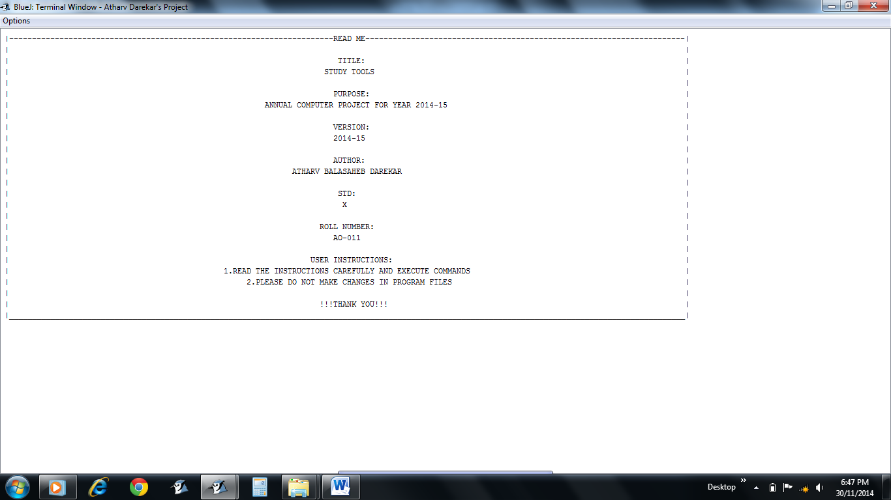

* Read Me / Introduction of the **Study Tools**

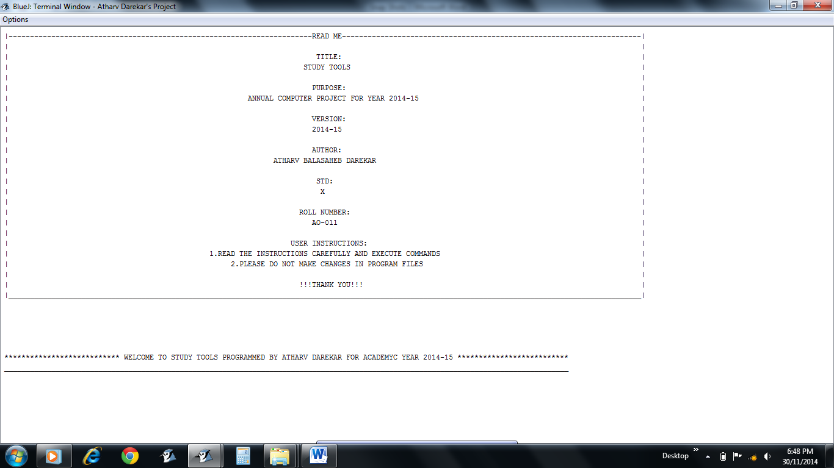

* Greeting Message

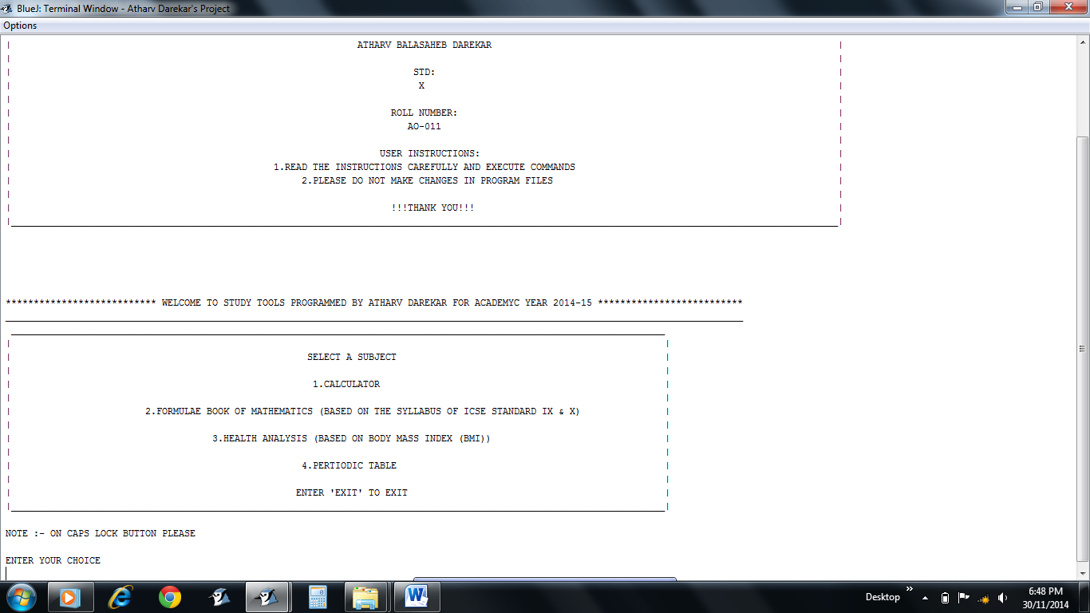

* Main Menu
* Read the instruction given “NOTE :- ON CAPS LOCK BUTTON PLEASE” and follow it

**CALCULATOR**

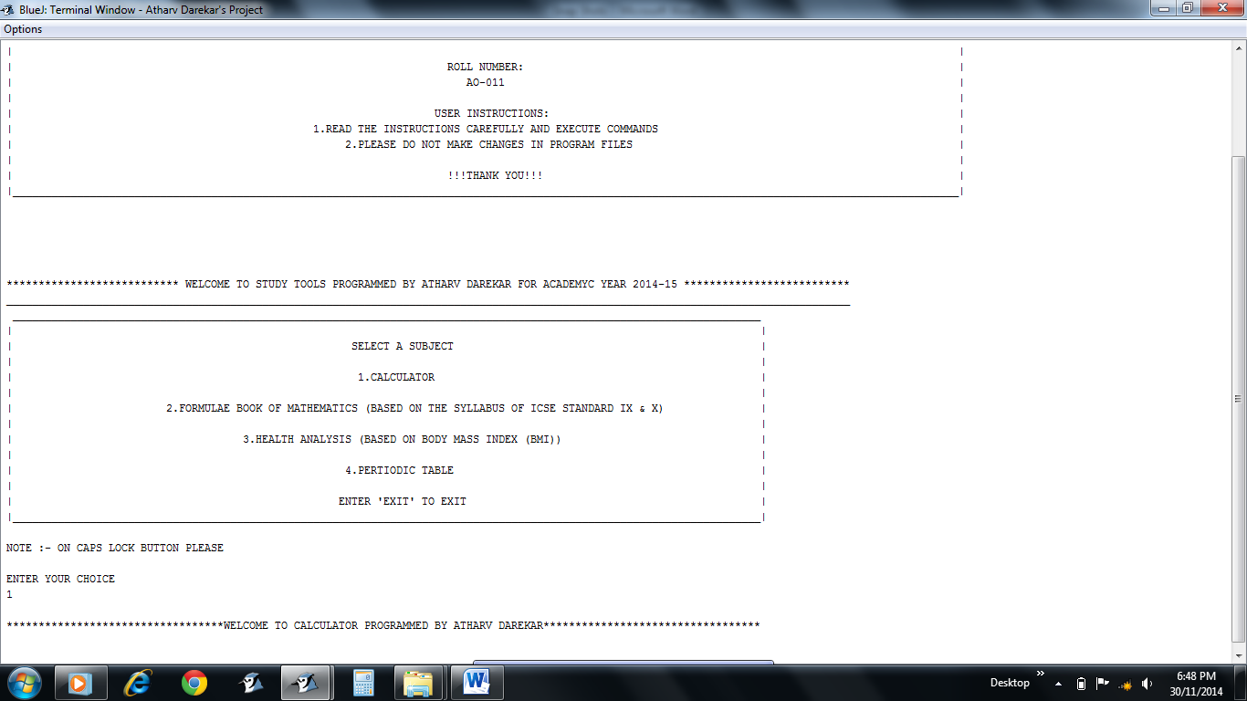

* 1 option for CALCULATOR
* Greeting Message

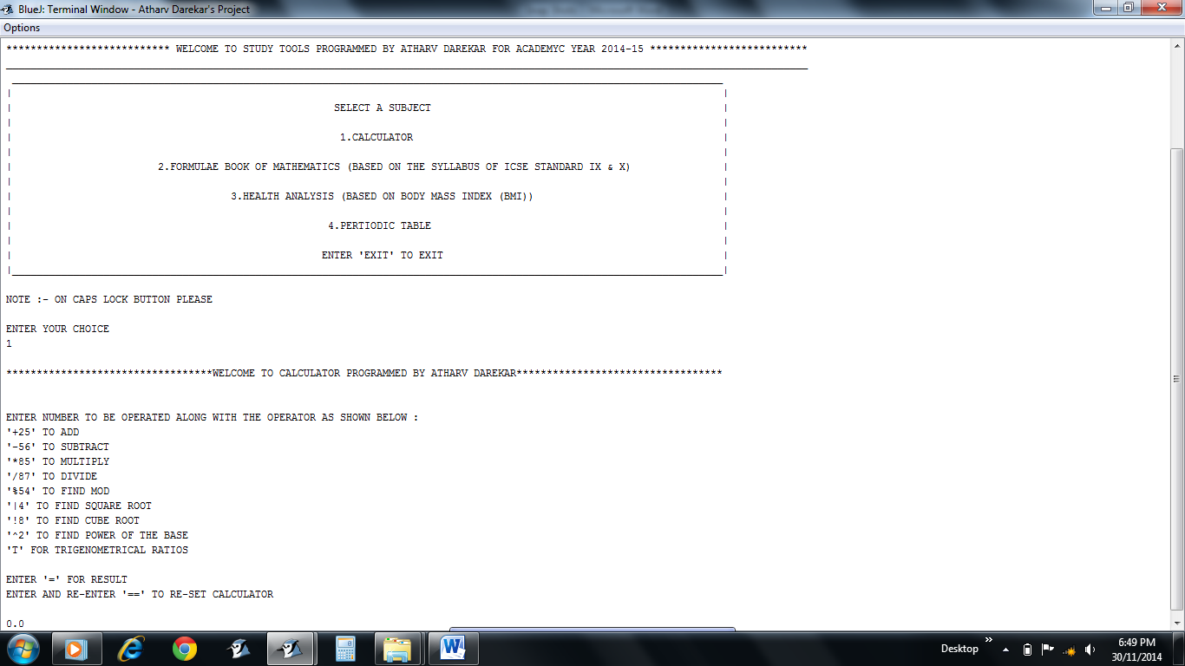

* Instructions given for giving input
* CALCULATOR showing 0.0 as initial value

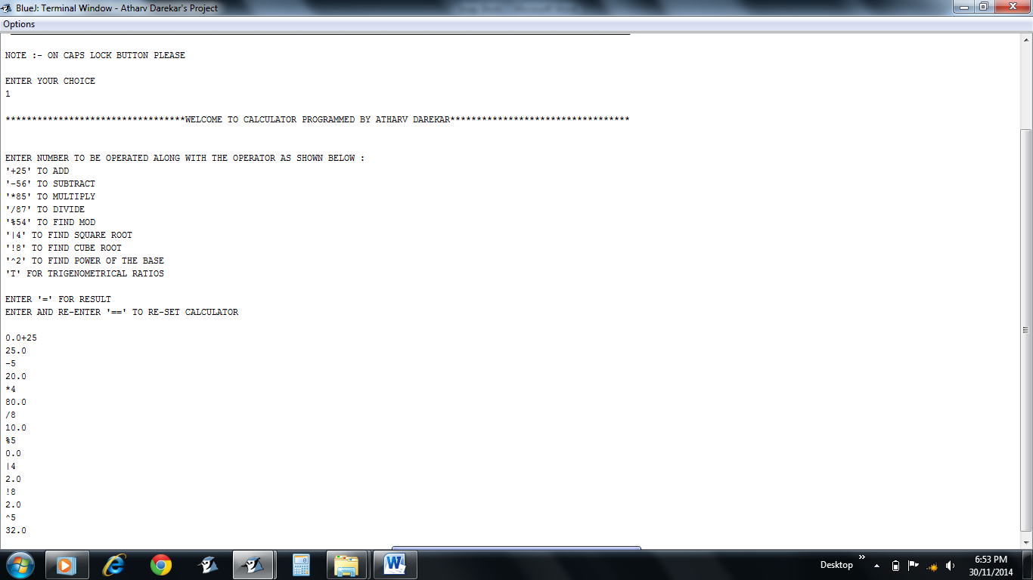

* Various operations done

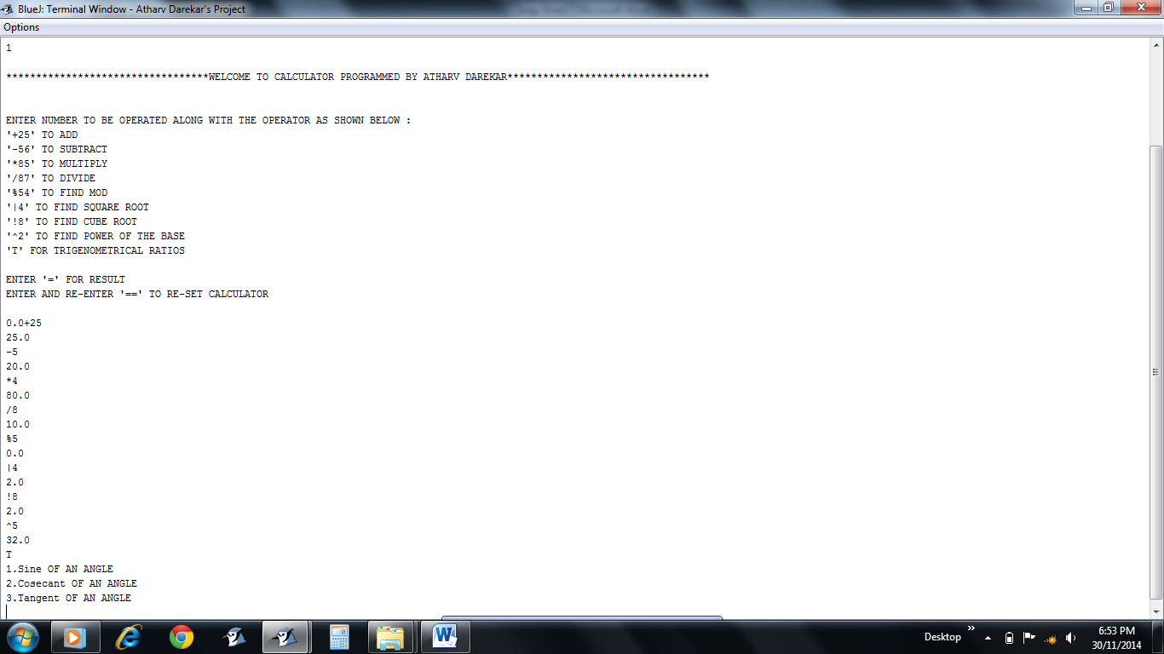

* T option for calculating trigonometric values

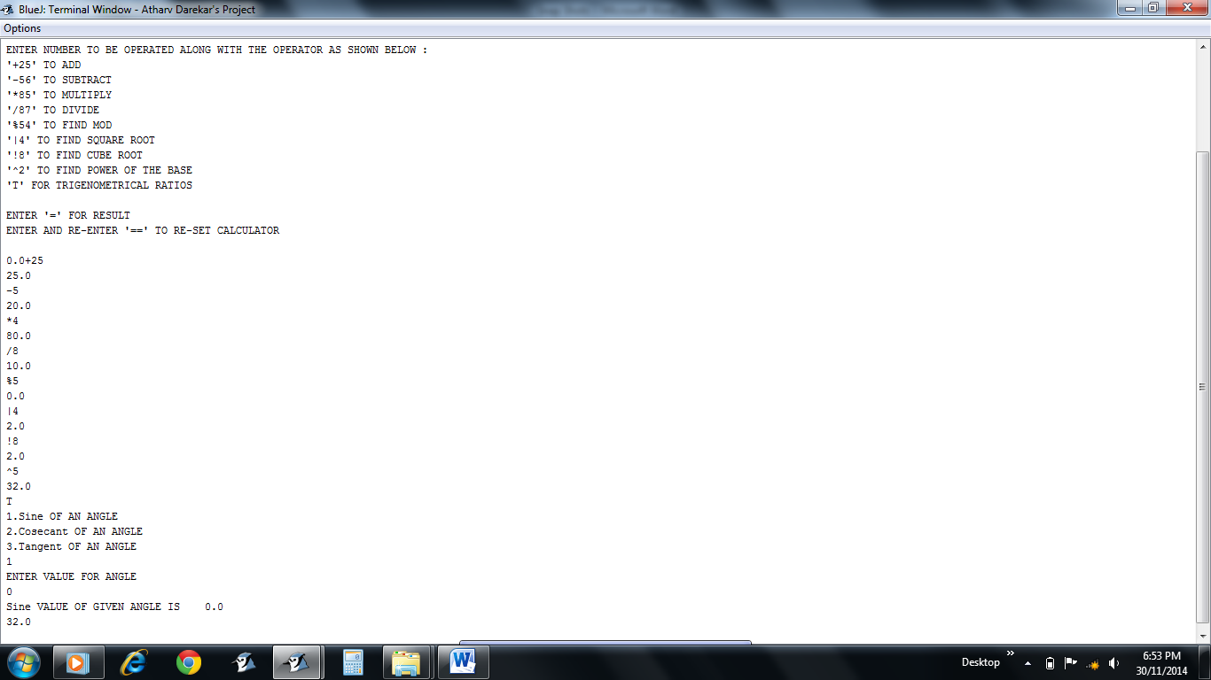

* Users choice according to requirement for calculating the trigonometric value

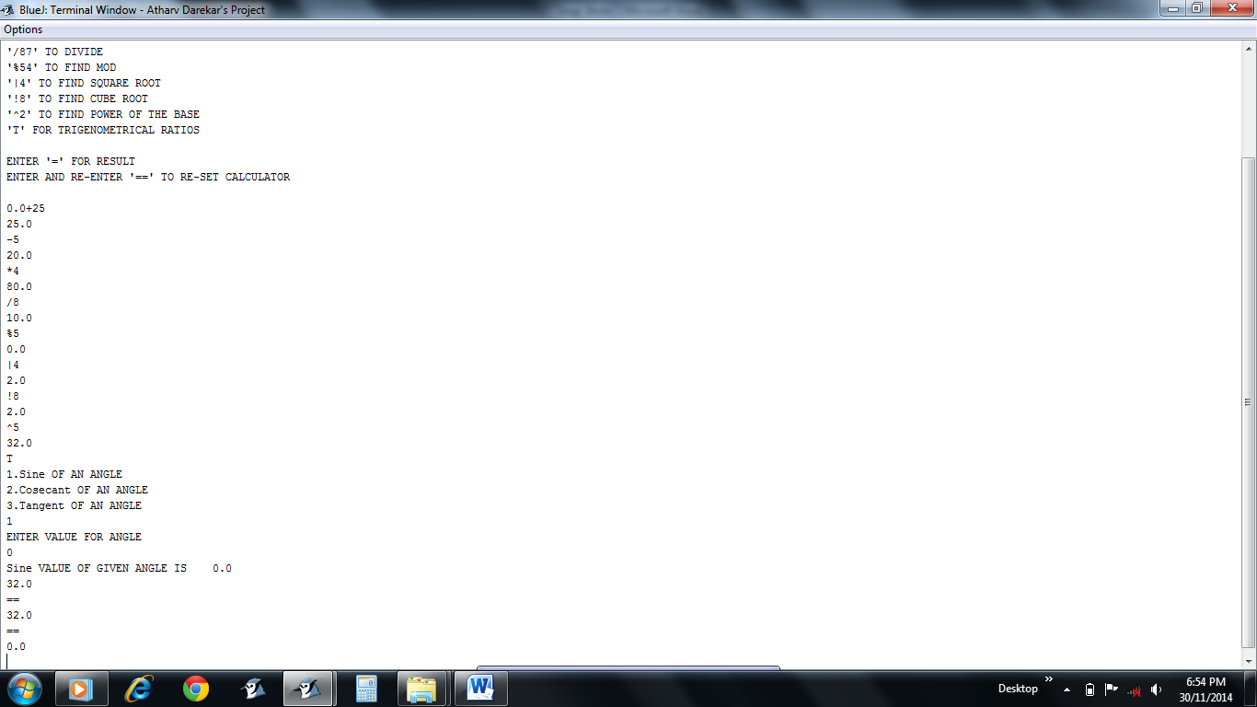

* Enter and Re-Enter “==” to reset the CALCULATOR

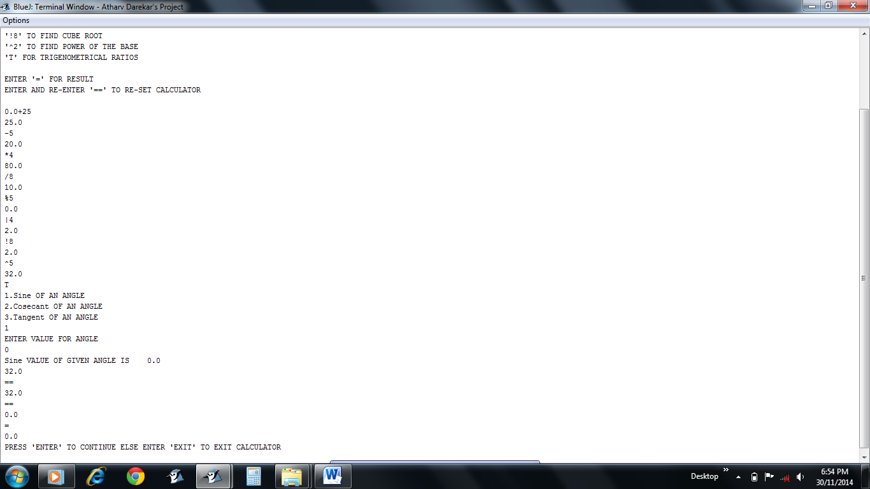

* “=” for final result as well as to quit the CALCULATOR

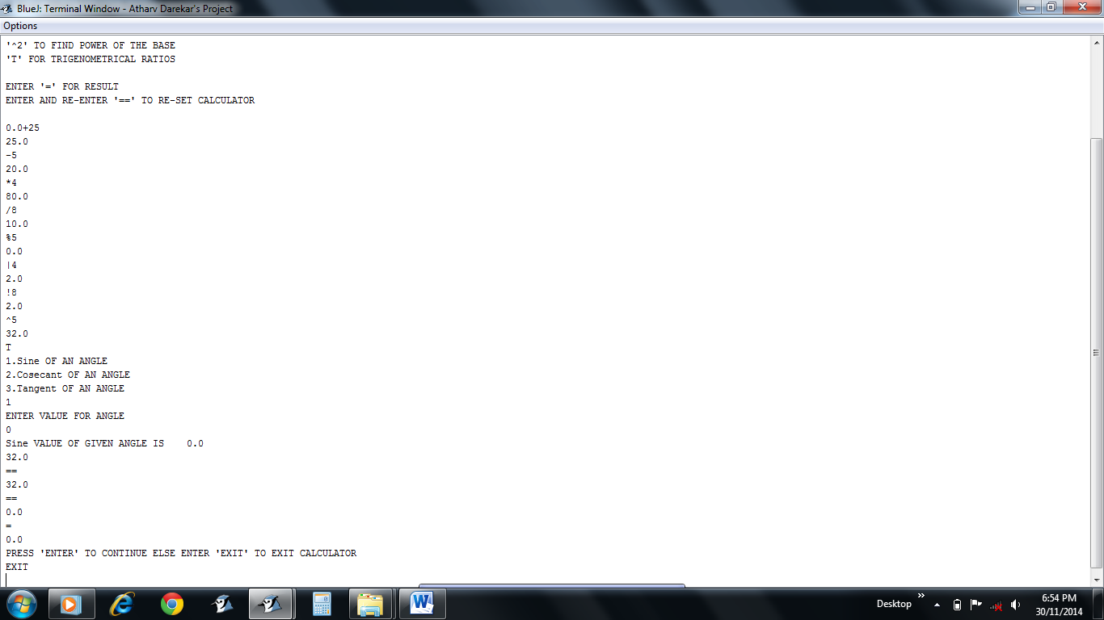

* “EXIT” command to exit the CALCULATOR
* Press ENTER to continue instead

**FORMULAE BOOK FOR MATHEMATICS**

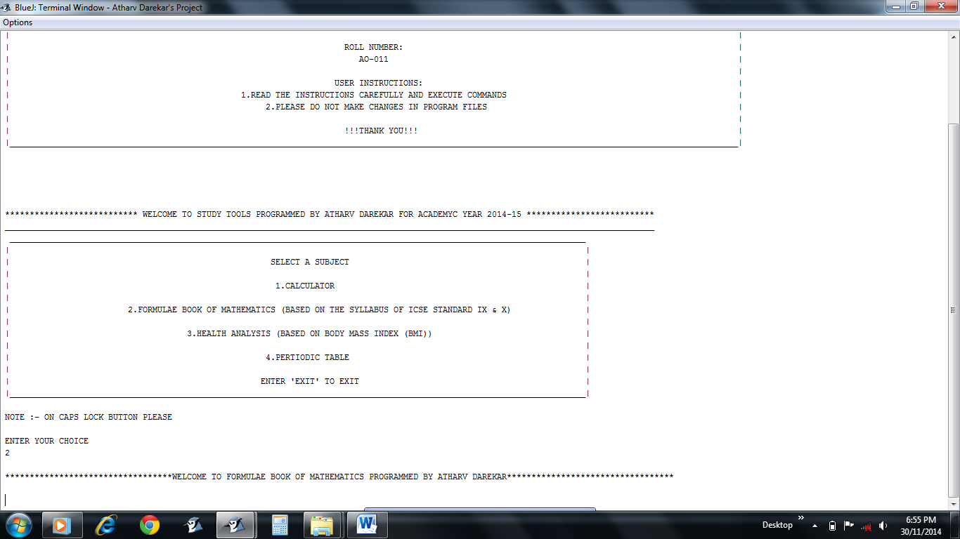

* 2 option for FORMULAE BOOK OF MATHEMATICS
* Greeting Message

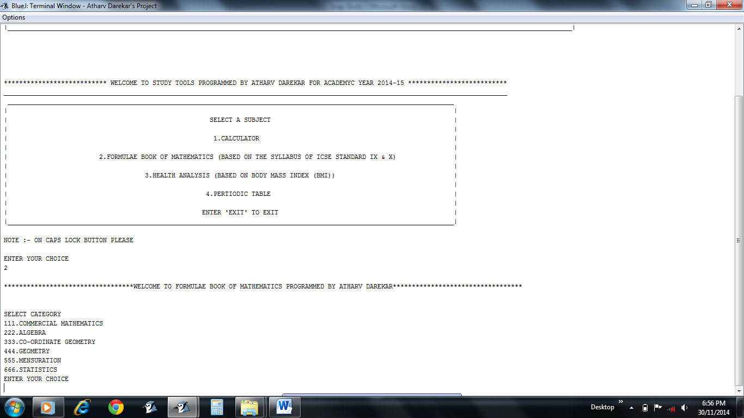

* Category to be selected by the user according to the requirement

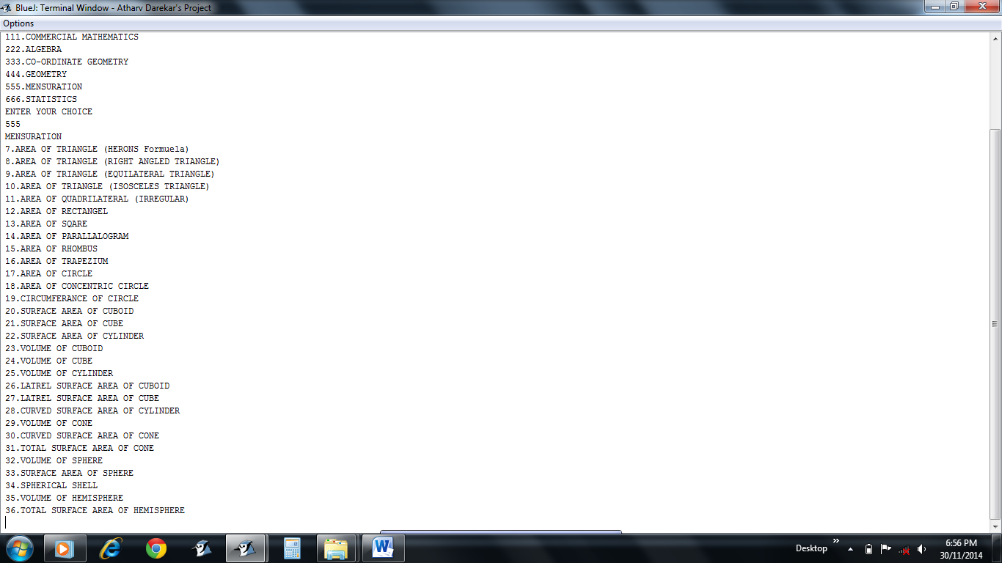

* 555 for MENSURATION category
* User has to choose the specific option as required

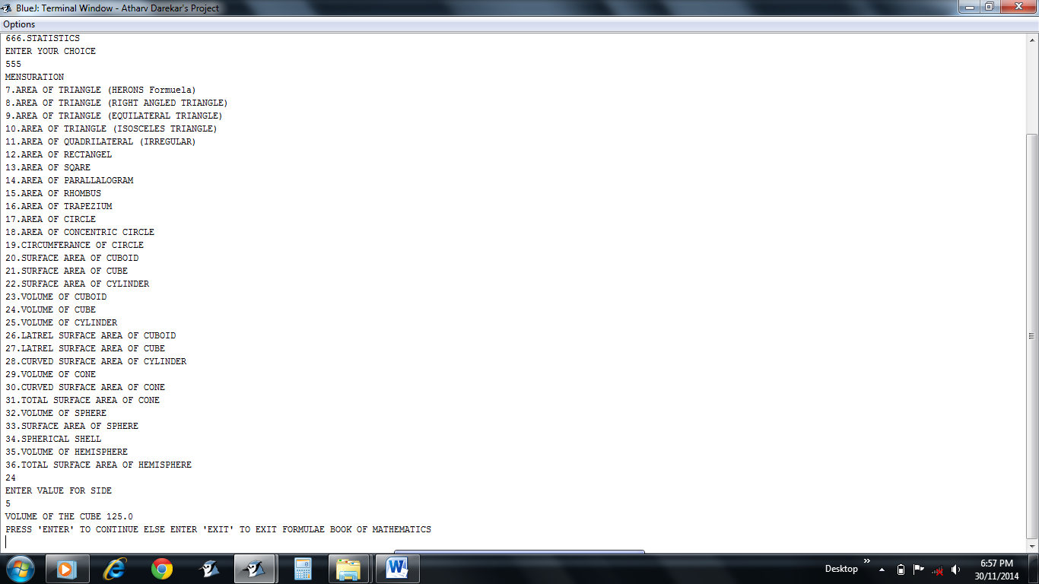

* 24 option to find VOLUME OF CUBE
* Result displayed

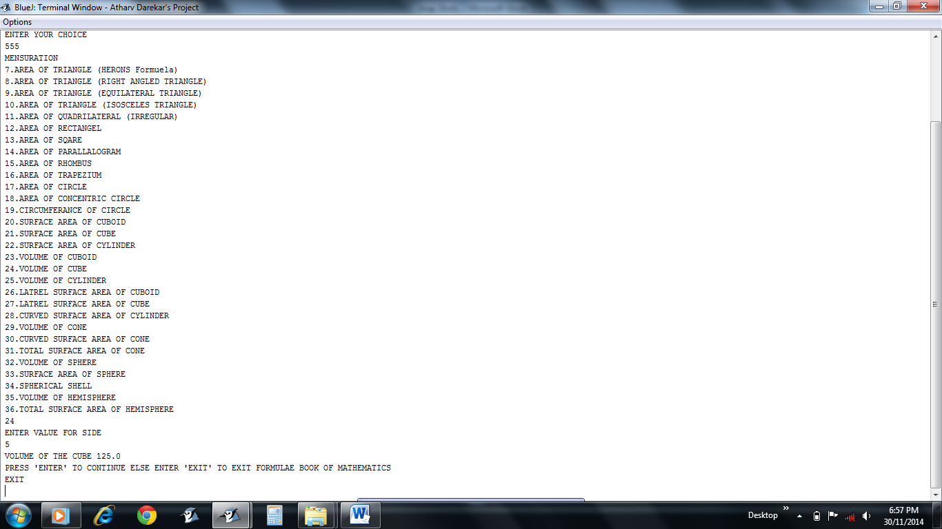

* “EXIT” command to quit FORMULAE BOOK FOR MATHEMATICS
* Press “ENTER” to continue instead

**HEALTH ANALYSIS**

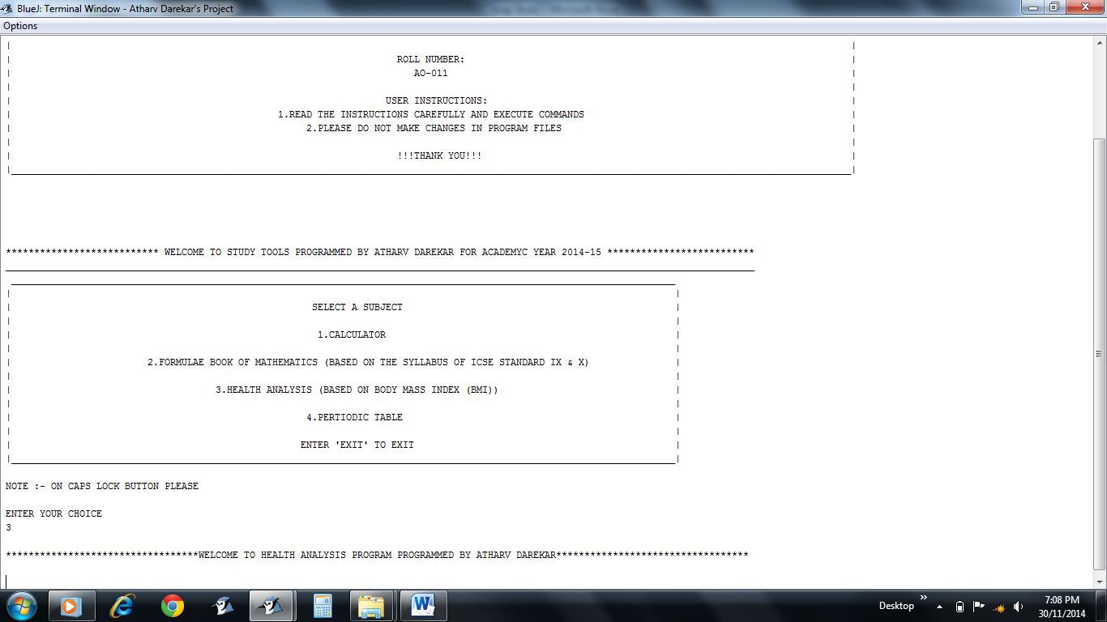

* 3 option for HEALTH ANALYSIS
* Greeting Message

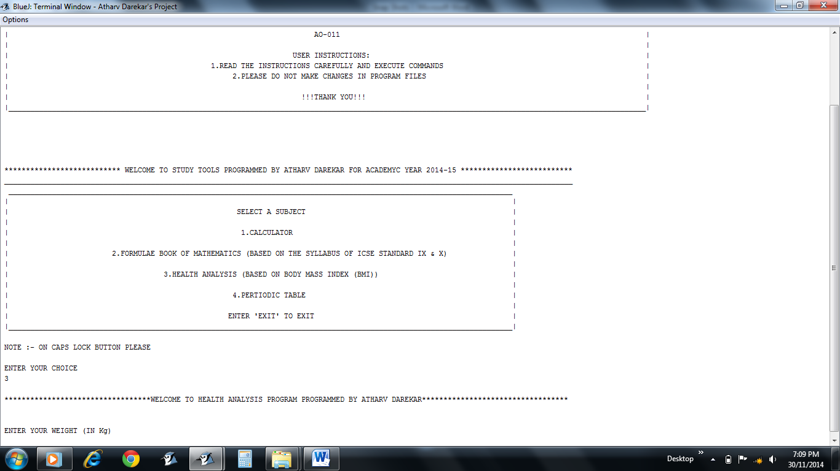

* Required input to calculate BMI

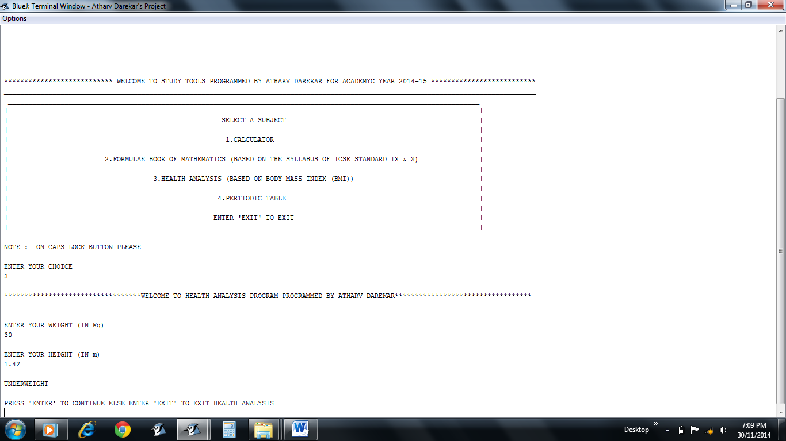

* Required input to calculate BMI
* Status as calculated by the Application

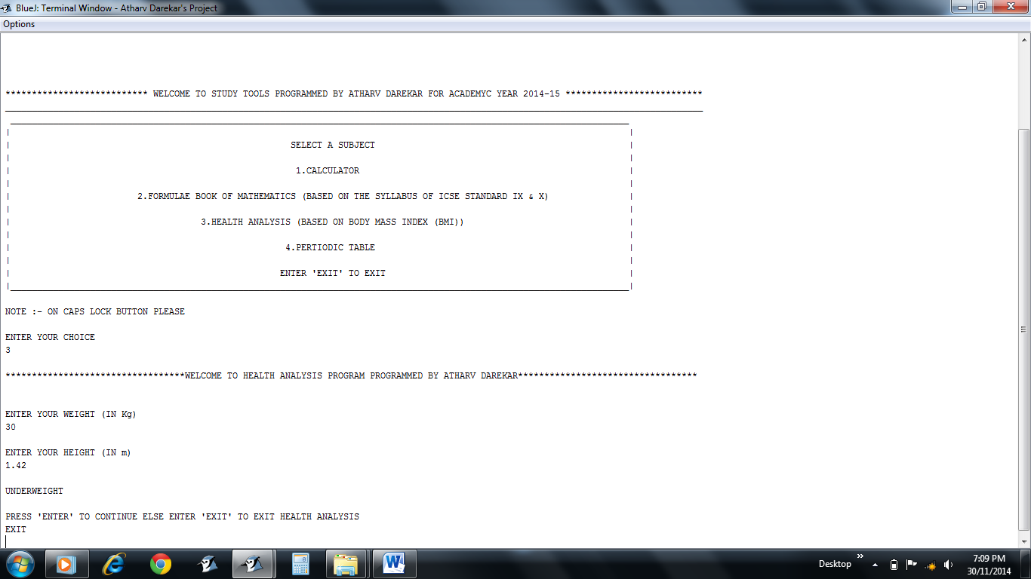

* “EXIT” command to quit HEALTH ANALYSIS
* Press “ENTER” to continue instead

**PERIODIC TABLE**

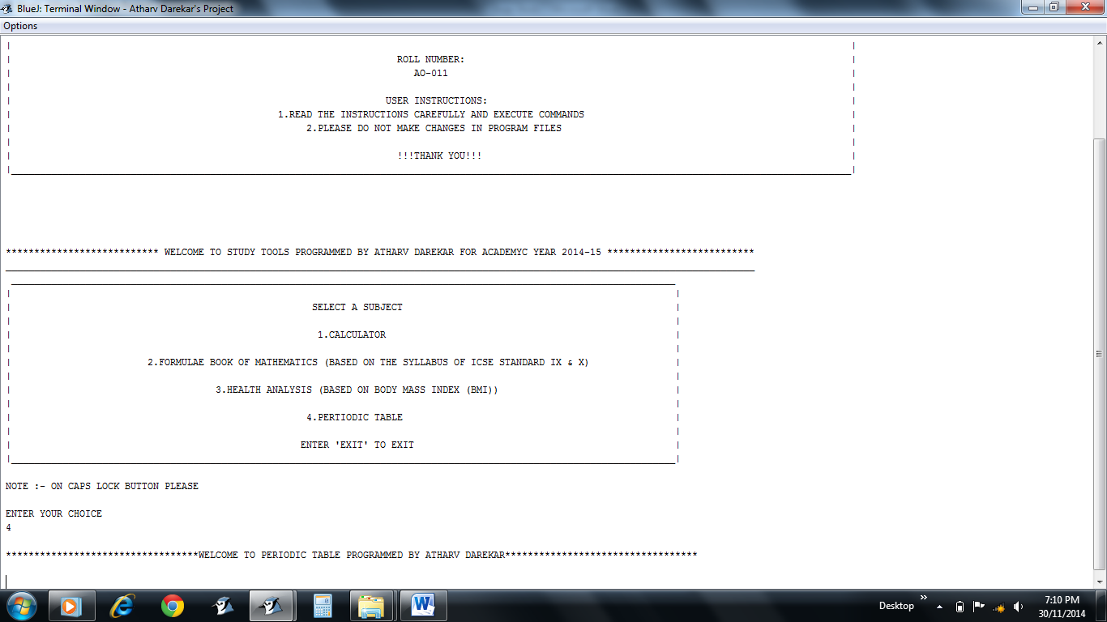

* 4 option for PERIODIC TABLE
* Greeting Message

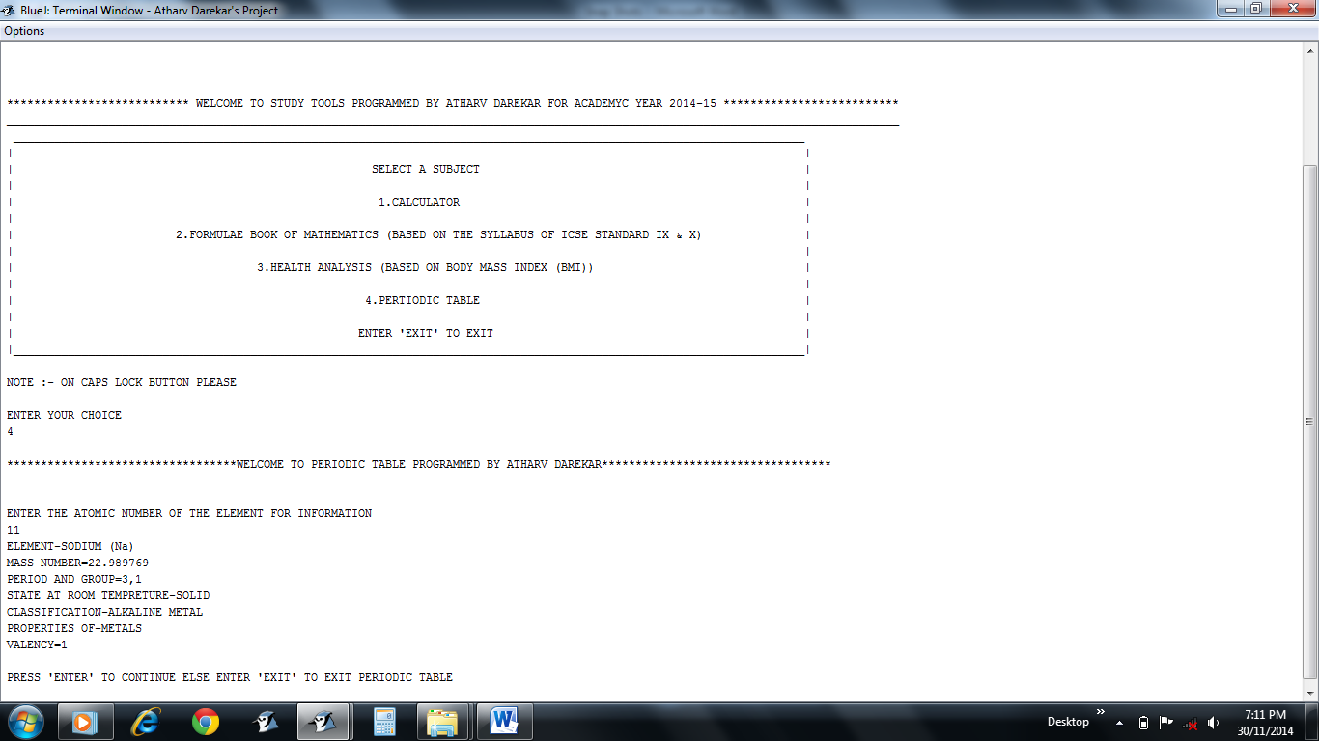

* According to input of the user the information of the respective element is displayed
* Message either to continue else to exit

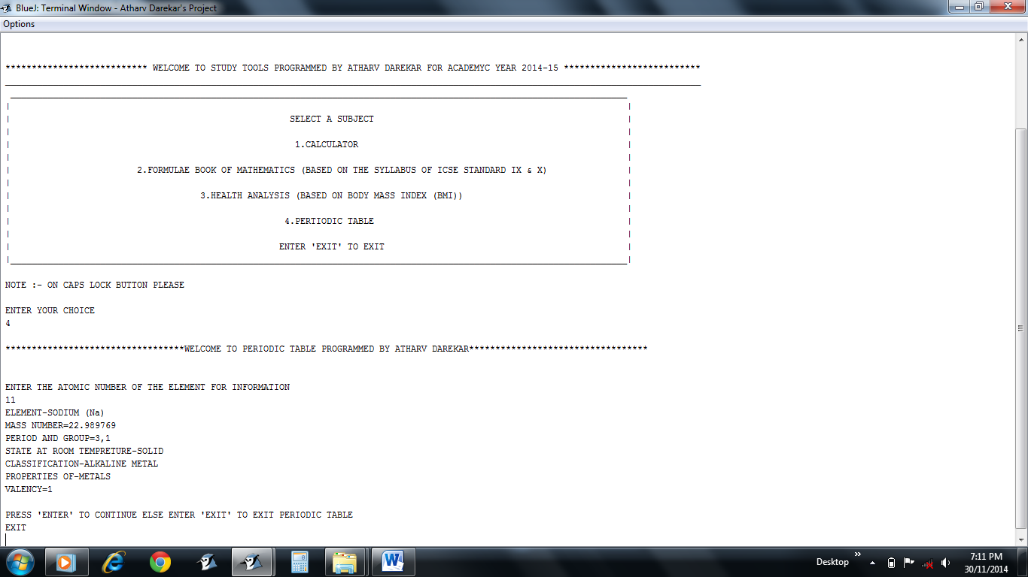

* “EXIT” command to quit PERIODIC TABLE
* Press “ENTER” to continue instead

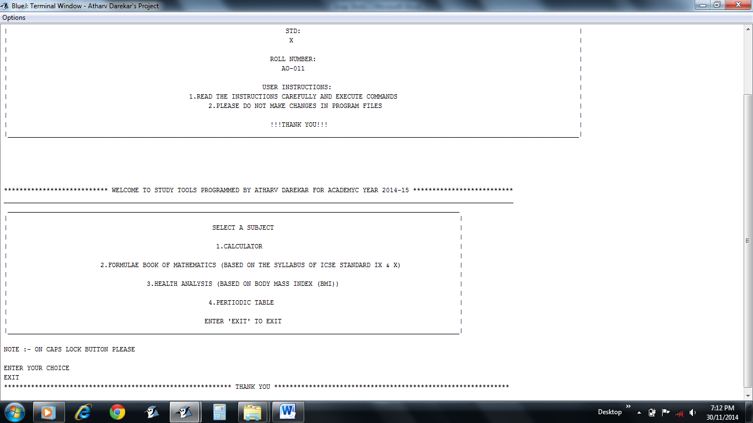

* “EXIT” command to quit MAIN MENU
* Choose a option to continue instead

**Demonstrating Run Time Error Fixation Feature of the “STUDY TOOLS” program**

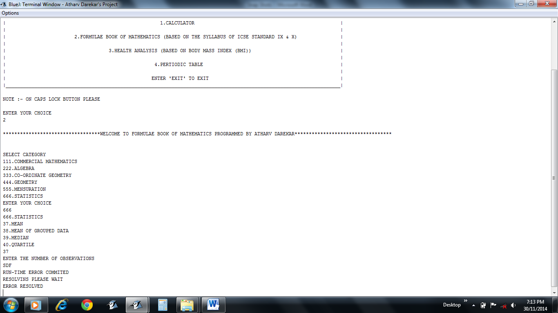

Here the input was required as double but if user gives input as character or string generally the program terminates but here the error is resolved and user can resume with the work again